Appendix 1
Table 1: Complexity concepts for analysis of system change, as per Phase 2 of the McGill framework⁶
Complexity concept | Definition (6: p. 17)
1. Nonlinearity | “Inputs into the system do not necessarily result in correspondingly sized effects in the system; nonlinear relationships do not follow simple input-output line.”
2. Feedback loops | “Positive or negative response that may alter the intervention and its impacts. Positive feedback loops: change amplifies further change; negative feedback loops: change dampens down further change.”
3. Adaptation | “Adjustments in system behaviour in response to internal and external change.”
4. Dynamism | “Change in the state of the system that happens over time; time and evolution.”
5. Emergent properties | “Properties of a complex system that cannot be directly predicted from the elements within it and are more than just the sum of its parts; collective behaviours.”
6. Co-evolution | “System change in response to its environment or another system; both systems change and evolve as a result.”
7. Unintended consequences | “As a result of nonlinearity and feedback loops, complex systems are characterized by unanticipated processes and outcomes.”
8. System trajectories | “[…]Qualitatively, the path a system follows through time, moving through different states, including periods of stability and instability.”

Appendix 2:

Interview topic guide
The interview topic guide consisted of the below questions, developed based on the research objective:
- Please tell me about any actions in the Action Plan that you have worked on implementing.
- Taking a broad perspective, what, if anything, has happened as a result of these actions so far, directly or indirectly?
- Has anything unexpected happened as a result of these actions - for example, any unexpected additional benefits or any unexpected consequences?
If yes:
- Please tell me more about this, and why you think it happened.

Appendix 3
The thematic framework developed and used to classify interview transcripts is displayed in Table 2 below.
Table 2: Thematic framework
Main theme | Sub-themes
1. Pre-existing actions included in the action plan | Type of action
1. Pre-existing actions included in the action plan | WSA impact
1. Pre-existing actions included in the action plan | Covid-19 impact
2. Outcomes of new actions implemented as part of the action plan | Type of action
 | Type of outcome
 | Unexpected effects
 | Covid-19 impact
3. General impacts of implementation of PHE guidance | Healthy Places Co-ordinator
3. General impacts of implementation of PHE guidance | Knowledge of wider determinants of obesity
3. General impacts of implementation of PHE guidance | Partnership working
3. General impacts of implementation of PHE guidance | Community knowledge

In relation to the first main theme above, ‘Pre-existing actions included in the action plan’, it became clear at the data collection stage that many of the actions included in the action plan had already been ongoing prior to implementation of the PHE guidance. Data on such pre-existing actions was not directly relevant to the research aim - thus, the outcomes of these actions were not considered relevant, and were not probed in interviews. However, interviewees were asked about whether and how inclusion of these actions in the action plan may have impacted their implementation – this data was grouped under the sub-theme ‘WSA impact’.
Data relating to ‘new’ actions (developed as a result of implementing the PHE guidance) was classified under the second main theme, ‘Outcomes of new actions implemented as part of the action plan’. This theme was the only one developed deductively from the research objective, as were its sub-themes, apart from ‘Covid-19 impact’ (on implementation and outcomes of actions), a topic which was raised frequently by participants, in relation to both pre-existing and new actions.
The focus of the research objective was on the impact of implementing the action plan, as opposed to the guidance more generally, on the local obesity system. However, interviewees often raised the topic of the general impacts of implementing the PHE guidance (i.e. the process of mapping the obesity system and developing the action plan). Thus, this topic constituted the third main theme.

Appendix 4

System narrative

Creation of a new role – an unintended consequence
A key unintended consequence, or rather benefit, of the implementation of the PHE guidance in East Sussex was that it significantly influenced the creation of a ‘Healthy Places Coordinator’ role in East Sussex CC. The remit of this post centres on addressing the wider determinants of health in relation to the built and natural environments, by working with planning authorities in the county to embed a ‘Health in All Policies’ approach. The term ‘wider determinants of health’ refers to the social, economic and environmental factors that influence people’s health.¹⁴
The quote below illustrates the impact that implementation of the PHE guidance, particularly mapping the obesity system, had on the creation of this new post.
“It [the action plan] had a big influence on […] the decisions that were then made, that this was an area of work [planning and the environment] that we wanted to do - didn't have time, capacity, again highlighted on that [obesity system] map that it's, it has a huge influence.”
(Participant 15)
The creation of the Healthy Places Coordinator post can be located in the ‘Workforce development’ thematic area of the obesity system map. It relates specifically to the ‘Workforce capacity’ element, illustrated in Figure 2 below.
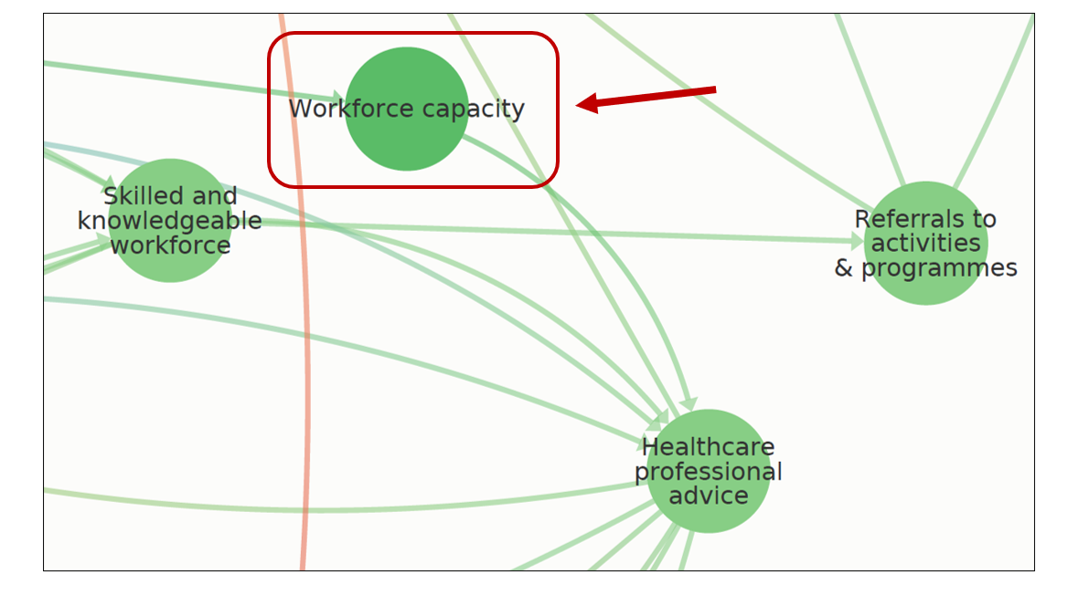
Figure 3: ‘Workforce development’ area of system map: ‘Workforce capacity’ element (Source: 8)

Increased knowledge of wider determinants of obesity – a positive feedback loop
Many participants said that implementation of the PHE guidance had increased their knowledge of the role of wider determinants of health as causal factors in obesity, as illustrated by the quote below.
“All of our actions previously were looking at sort of individual behaviours and not that kind of wider determinants work and areas, and so yeah that really, really was quite a stark contrast, that actually the causes of obesity are more about the environment that we exist within etc., and so that, it was a huge gap, so that's definitely been influenced by going through this process.”
(Participant 15)
There were a few examples in the data of participants applying the knowledge they gained on the wider determinants of obesity to other areas of their work, separate to the action plan – a pattern corresponding to the concept of a positive feedback loop, in which change propagates further change. For instance, one participant said that they planned to highlight the role of transport and active travel in relation to the obesity agenda in the Local Transport Plan (the CC transport strategy).
The increased knowledge of participants on the wider determinants of obesity, and potential positive feedback loop in relation to it, can also be located in the ‘Workforce development’ area of the system map. These findings relate specifically to the ‘Skilled and knowledgeable workforce’ element, illustrated in Figure 3 below.
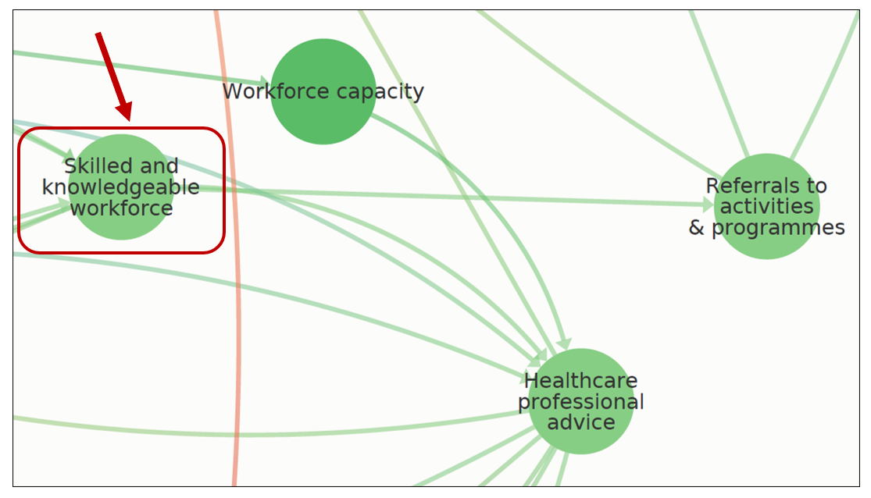
Figure 4: ‘Workforce development’ area of system map: ‘Skilled and knowledgeable workforce’ element (Source: 8)

Improved collaboration within the Partnership
The primary impact of implementation of the PHE guidance reported by participants was improved collaboration within the Partnership. As stated by one participant:
“I would say that the development of the action plan has really, some of the broader impacts has been around that partnership working and bringing partners together and identifying those partners that are not around the table.”
(Participant 16)
The main reason given by participants for the improved collaboration was that implementation of the PHE guidance had helped them to see how aligned their aims were with those of other partners, and that tackling obesity is a common goal.
Participants said that implementing the PHE guidance has strengthened existing relationships between partners and helped to bring in new, wider partners such as voluntary and community sector (VCS) organisations working on food poverty and other smaller VCS groups.
Some participants said that partners are contributing more actively to the Partnership now, and that it’s more “participatory”.
Improved collaboration, as a general impact of implementation of the PHE guidance, can also be located in the ‘Workforce development’ thematic area of the obesity system map; it does not map neatly onto a particular element, but the ‘Skilled and knowledgeable workforce’ element may be most relevant (as shown in Figure 3 above).
The above findings indicate that, to date, the three key general impacts of implementation of the PHE guidance may be limited to the ‘Workforce development’ part of the local obesity system map, as illustrated in Figure 4 below.
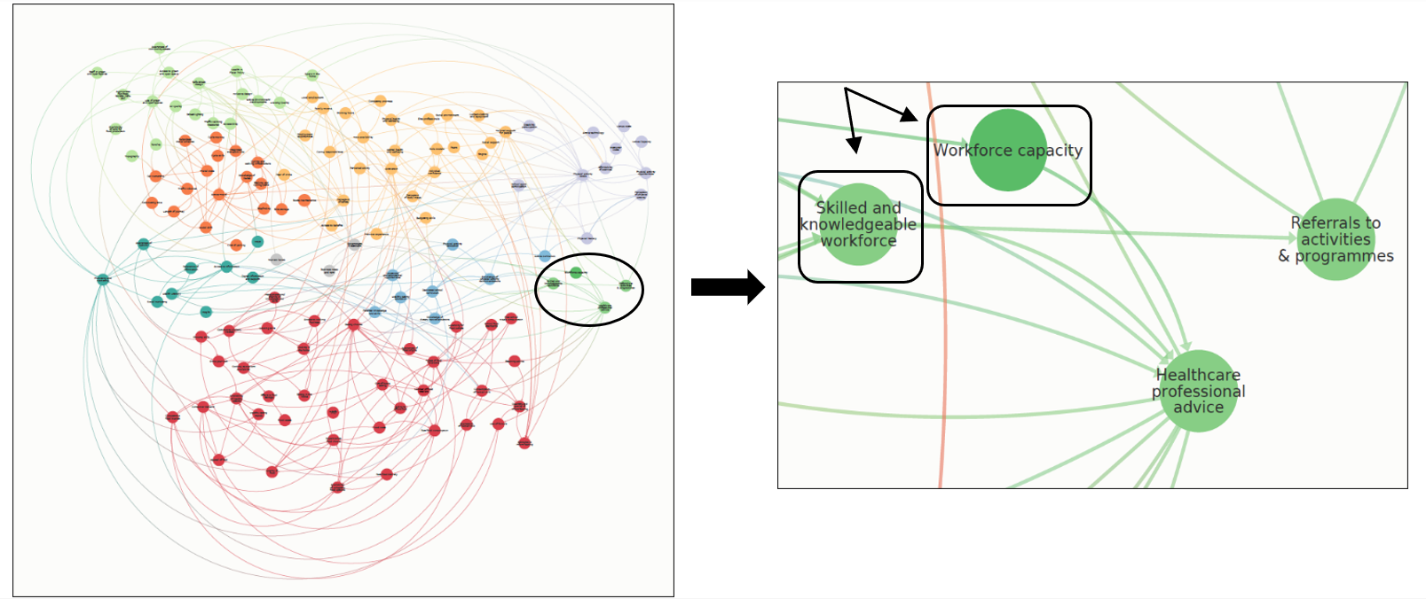
Figure 1: ‘Workforce development’ area of system map: System elements to which key impacts of implementation of the PHE guidance relate (Source: 8)

Impact of the Covid-19 pandemic – Adaptation in the obesity system
Participants gave a number of examples of the impact of the Covid-19 pandemic on their work that illustrated the concept of adaptation, i.e. adjustment in system behaviour to deal with this external system shock.⁶ For instance, in relation to the system elements of ‘Cycle training’ and ‘Active travel’, illustrated in Figure 5 below, one participant reported that in 2020, there had been the highest uptake ever by members of the public of an active travel training programme, and that staff had adapted the programme (usually delivered face-to-face through cycling and walking activities) for online delivery.
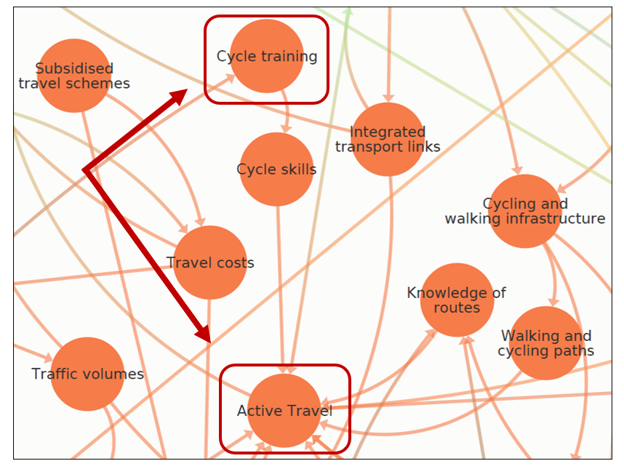
Figure 5: ‘Transport modes’ area: System elements to which adaptive system behaviour relates (Source: 8)

Appendix 5
Consolidated criteria for reporting qualitative studies (COREQ): 32-item checklist
No. Item | Guide questions/description | Notes
Domain 1: Research team and reﬂexivity
Personal Characteristics
1. Interviewer/facilitator | Which author/s conducted the interview or focus group? | UG conducted all interviews.
2. Credentials | What were the researcher’s credentials? E.g. PhD, MD | The research was carried out as part of a master’s degree in public health at the London School of Hygiene & Tropical Medicine (LSHTM).
3. Occupation | What was their occupation at the time of the study? | Public health specialty registrar and master’s student in public health
4. Gender | Was the researcher male or female? | Female
5. Experience and training | What experience or training did the researcher have? | UG had training in using qualitative methods, including conducting interviews, through the master’s degree course, and experience through previous public health roles.
Relationship with participants
6. Relationship established | Was a relationship established prior to study commencement? | No
7. Participant knowledge of the interviewer | What did the participants know about the researcher? e.g. personal goals, reasons for doing the research | Participants were aware that the researcher was completing a master’s degree in public health at LSHTM, and was carrying out the research in fulfillment of that degree.
8. Interviewer characteristics | What characteristics were reported about the interviewer/facilitator? e.g. Bias, assumptions, reasons and interests in the research topic | None reported due to limited word count. Through a previous local authority public health role in a London Borough, the researcher had considerable experience of implementing the PHE guidance. They were aware that sharing this information with interviewees could lead to perceived expert power, and thus a power imbalance. Hence, the researcher did not share this information as a matter of course – but only when judged to be relevant to build rapport.
Domain 2: study design
Theoretical framework
9. Methodological orientation and Theory | What methodological orientation was stated to underpin the study? e.g. grounded theory, discourse analysis, ethnography, phenomenology, content analysis | The study was underpinned by a complex systems perspective. Framework analysis was used – a thematic framework was developed, both deductively and inductively, and used to analyse the interview data.
Participant selection
10. Sampling | How were participants selected? e.g. purposive, convenience, consecutive, snowball | Purposive sampling was used to ensure that a range of different organisations within the Partnership were represented in the sample, and to ensure that information-rich cases were recruited.
11. Method of approach | How were participants approached? e.g. face-to-face, telephone, mail, email | Suitable interviewees were identified by the main point of contact for the research at East Sussex CC, together with her manager. They were then invited by email by the researcher to participate in the study.
12. Sample size | How many participants were in the study? | 17 interviewees
13. Non-participation | How many people refused to participate or dropped out? Reasons? | None
Setting
14. Setting of data collection | Where was the data collected? e.g. home, clinic, workplace | Online using Zoom
15. Presence of non-participants | Was anyone else present besides the participants and researchers? | No
16. Description of sample | What are the important characteristics of the sample? e.g. demographic data, date | Interviewees were representatives of East Sussex County Council (CC) and eight other organisations in the Healthy Weight Partnership, as outlined below:  - East Sussex CC: Public health, transport, early years and trading standards teams  - Sustrans (a national walking and cycling charity)  - Hastings Borough Council: Active Hastings Partnership  - Rother District Council: Active Rother Partnership  - South Downs National Park  - East Sussex Fire and Rescue Service  - University of Brighton  - Active Sussex (Partnership)  - One You East Sussex (a health and wellbeing service provider)
Data collection
17. Interview guide | Were questions, prompts, guides provided by the authors? Was it pilot tested? | Yes, the interview topic guide is presented in Appendix 2.  It was not pilot tested because the priority was to maximise the final sample size to ensure as many types of participants as possible were recruited and to increase the chance of saturation being reached. The Healthy Weight Partnership was the only sampling frame available, as the group with knowledge of and responsibility for the action plan, and as it is best practice when pilot testing not to include the pilot sample in the final sample to prevent bias, pilot testing would have reduced the final sample size.
18. Repeat interviews | Were repeat interviews carried out? If yes, how many? | No
19. Audio/visual recording | Did the research use audio or visual recording to collect the data? | Interviews were carried out online using Zoom software (with video). They were recorded (audio only) and automatically transcribed using this software, with participants’ permission.
20. Field notes | Were ﬁeld notes made during and/or after the interview or focus group? | The researcher made notes during the interviews to focus and guide questions – however, only the transcripts were used for data analysis.
21. Duration | What was the duration of the interviews or focus group? | Interviews were approximately 45 minutes long.
22. Data saturation | Was data saturation discussed? | It was not explicitly discussed, as the sample size was pre-determined, rather than being determined by the point at which saturation was reached, which was not possible due to time constraints. However, saturation did occur, with key patterns repeating in the data – future studies could use a smaller sample size.
23. Transcripts returned | Were transcripts returned to participants for comment and/or correction? | No – the audio recording was referred back to.
Domain 3: analysis and ﬁndings
Data analysis
24. Number of data coders | How many data coders coded the data? | One - UG
25. Description of the coding tree | Did authors provide a description of the coding tree? | N/A
26. Derivation of themes | Were themes identiﬁed in advance or derived from the data? | Both – framework analysis involves developing a ‘thematic framework’ (see Appendix 3) to classify the data in terms of main themes and sub-themes, which are developed both deductively, based on research objectives, and inductively, based on the data itself, following familiarization.
27. Software | What software, if applicable, was used to manage the data? | NVivo
28. Participant checking | Did participants provide feedback on the ﬁndings? | No – however, the project report was shared with them.
Reporting
29. Quotations presented | Were participant quotations presented to illustrate the themes/ﬁndings? Was each quotation identiﬁed? e.g. participant number | Yes, quotations were presented and identified using participant numbers.
30. Data and ﬁndings consistent | Was there consistency between the data presented and the ﬁndings? | All findings were derived from the data and supported by illustrative quotes. However, raw/anonymized data was not presented to protect confidentiality.
31. Clarity of major themes | Were major themes clearly presented in the ﬁndings? | Yes, major themes were presented as a narrative describing the changes identified in the obesity system, supported by visual depiction of the location of changes on excerpts of the system map.
32. Clarity of minor themes | Is there a description of diverse cases or discussion of minor themes? | No, due to limited word count. However, deviant cases were discussed in the original thesis manuscript.

