Staged meta-analysis of randomised trials testing triclosan coated sutures on surgical site infection after abdominal surgery using a modified Risk of Bias-2 tool
Table of Contents
Table S1. Quality assessment of randomised controlled trials adapted from the domains of the Cochrane Risk of Bias-2 tool, modified for interventions to reduce of surgical site infections 3
Table S2. Summary of the search terms used for the systematic review. 5
Table S3. Reasons of the excluded studies on full text review 6
Table S4. Comparisons of the studies included in the present review compared to previous reviews 8
Table S5. Summary of the quality assessment of randomised trials included in the systematic review assessed using the modified Cochrane risk of bias tool, showing domains and types of bias essential to trials in SSI 9
Table S6. Patient and treatment characteristics of high-quality randomised controlled trials for suture types included in the review 10
Table S7. Technical details in the use of the coated and uncoated sutures in terms of layer closed and type of sutures 11
Figure S1. Funnel plot assessing publication bias for all randomised trials for suture types 12
Figure S2. Funnel plot assessing publication bias for by included low-quality and high-quality randomised trials for suture types 13
Figure S3. Simulations of an ongoing high-quality trial on overall meta-analysis findings including 500 patients in each arm (A) No effect (B) 10% reduction (C) 20% reduction (D) 30% reduction (E) 40% reduction 14

Table S1. Quality assessment of randomised controlled trials adapted from the domains of the Cochrane Risk of Bias-2 tool, modified for interventions to reduce of surgical site infections

Cochrane ROB-2 Domains | Modified Domains for interventions to reduce SSIs | Type of Bias | Definition of low risk | Assessment | Essential
Randomisation process | Random sequence generation | Selection | Randomisation of patients using validated methodology, that included centralised, computer or web-based generation, but excluded mechanical methods that could potentially be manipulated, such as shuffling of cards. Quasi randomisation or randomisation based on surgeons’ judgement, preference, or availability were excluded. | Low risk: Valid randomisation methodology  High risk: None or unclear randomisation methodology | Yes
Randomisation process | Allocation concealment | Selection | Acceptable method for assigning participants to comparison groups without risk of prior knowledge of an upcoming allocation. Low risk methods include central allocation and randomly mixed block sizes. | Low risk: Valid allocation methodology  High risk: None or unclear allocation methodology | Yes
Randomisation process | Baseline differences between intervention groups | Selection | No significant differences between the baseline demographics of the intervention and control groups. Recognition, analysis, and control of baseline differences between groups | Low risk: analysis and appropriate control for baseline differences  High risk: lack of recognition and/or control for baseline differences | Yes
Deviations from intended interventions | Blinding of surgeons | Performance | Blinding of surgeons performing the procedure is not possible and unlikely to be a source of bias, as long as unblinded surgeons do not also perform outcome assessment. | Low risk: Independent, blinded surgeon delivering intervention  High risk: No independent, blinded surgeon delivering intervention | No
Deviations from intended interventions | Blinding of patients | Performance | Blinding of patients to sutures is possible, and therefore an important method of reducing performance bias. | Low risk: Patients blinded  High risk: Patients not blinded | No
Deviations from intended interventions | Analysis of groups to which they were randomised | Attrition | Complete reporting of follow up of all patients including protocol deviations, deaths and loss to follow up. An ITT analysis is highly desirable. Modification for loss to follow-up (i.e., patients who did not complete 30-day follow-up) or in those where a wound could not be assessed who did not undergo surgery post-randomisation) was still considered low risk. Exclusion of patients in whom wounds could be assessed (e.g. incorrect allocation) and per protocol only analysis without adequate description of patients lost to follow up were considered to be high risk. | Low risk: Intention to treat analysis performed, and/or full reporting of protocol deviations and lost to follow up  High risk: No intention to treat analysis performed or incomplete reporting | Yes
Missing outcome data | Missing outcome data | Loss to follow-up | Acceptable level of loss to follow-up <20% in patients who survived at 30 days. Sensitivity analysis around missing outcome data is preferable to demonstrate that missing results do not affect the overall outcome of the analysis. | Low risk: Loss to follow-up <20%  High risk: Loss to follow-up ≥20% | Yes
Measurement of the outcome | Blinding of outcome assessors | Detection | As diagnosis of surgical site infection, is a structured but subjective assessment, blinding of outcome assessors is essential. Appropriate training of the outcome assessor should also be provided. | Low risk: Blinded outcome assessor  High risk: Unblinded, untrained outcome assessor | Yes
Measurement of the outcome | Quality assurance of outcome assessment | Outcome definition | A formal definition of SSI was used | Low risk: Valid definition stated  High risk: Definition not stated, or invalid | Yes
Measurement of the outcome | Quality assurance of outcome assessment | Follow up period pre-defined | Follow up intervals were pre-defined and standardised for each participant. | Low risk: Follow-up defined  High risk: Follow-up not defined | Yes
Measurement of the outcome | Quality assurance of outcome assessment | Post discharge surveillance | A process for wound assessment was established for post-discharge assessment at time of primary outcome evaluation. Reliance on ad hoc re-admissions or notes only reviews were considered at high risk of bias. | Low risk: Pre-specified post discharge wound assessment plan  High risk: No pre-specified post discharge wound assessment plan | Yes
Selection of the reported results | Reporting | Selective reporting | Reporting of the primary outcome matched the pre-published/registered protocol. | Low risk: Complete, pre-specified primary outcome reporting  High risk: Incomplete, pre-specified primary outcome reporting | Yes
Selection of the reported results | Reporting | Protocol registration | The study protocol should have been published or registered on a recognised trials registry in the public domain. | Low risk: Protocol published/registered  High risk: Protocol not published/registered | Yes
Definition of a high quality RCT: We defined a high quality RCT as one that was at low risk of bias across all of the domains stated above. Where the assessment was unclear, this constituted a risk of bias. Abbreviations: ITT: intention-to-treat, SSI: surgical site infection

Table S2. Summary of the search terms used for the systematic review.

1 | exp Surgical Wound Infection/ | 37176
2 | surgical site infection.ti,ab. | 7397
3 | wound infection.ti,ab. | 17834
4 | SSI.ti,ab. | 6863
5 | SSI's.ti,ab. | 2421
6 | 1 or 2 or 3 or 4 or 5 | 55708
7 | Antimicrobial-coated sutures.ti,ab. | 10
8 | exp Sutures/ | 17695
9 | suture.ti,ab. | 46342
10 | sutures.ti,ab. | 23331
11 | triclosan.ti,ab. | 3534
12 | 7 or 8 or 9 or 10 or 11 | 70522
13 | randomized controlled trial.pt. | 523981
14 | controlled clinical trial.pt. | 94083
15 | randomized.ab. | 499439
16 | placebo.ab. | 212425
17 | clinical trials as topic.sh. | 194888
18 | randomly.ab. | 346626
19 | trial.ti. | 229765
20 | 13 or 14 or 15 or 16 or 17 or 18 or 19 | 1330259
21 | exp animals/ not humans.sh. | 4793399
22 | 20 not 21 | 1223329
23 | 6 and 12 and 22 | 634

Table S3. Reasons of the excluded studies on full text review

Study reference | Reason for exclusion
Erfan MA, Thabet EAM, Rageh MA, Mohy SM, El Wardany I. The effect of triclosan-coated sutures on the incidence of surgical site infection in laparoscopic sleeve gastrectomy, laparoscopic appendicectomy or laparoscopic cholecystectomy: A multi-centre, double-blind, randomized, intra-individual study. Int Wound J. 2024 Jan;21(1):e14387. doi: 10.1111/iwj.14387. Epub 2023 Sep 13. PMID: 37705324; PMCID: PMC10784617. | No reporting of overall surgical site infection for all patients
Renko M, Paalanne N, Tapiainen T, Hinkkainen M, Pokka T, Kinnula S, Sinikumpu JJ, Uhari M, Serlo W. Triclosan-containing sutures versus ordinary sutures for reducing surgical site infections in children: a double-blind, randomised controlled trial. Lancet Infect Dis. 2017 Jan;17(1):50-57. doi: 10.1016/S1473-3099(16)30373-5. Epub 2016 Sep 19. PMID: 27658562. | No stratified by contamination
Tabrizi R, Mohajerani H, Bozorgmehr F. Polyglactin 910 suture compared with polyglactin 910 coated with triclosan in dental implant surgery: randomized clinical trial. Int J Oral Maxillofac Surg. 2019 Oct;48(10):1367-1371. doi: 10.1016/j.ijom.2019.01.011. Epub 2019 Feb 6. PMID: 30738711. | Non-abdominal surgery - dental implants
Clinical Equivalence of Polyglycolic Acid Suture and Polyglactin 910 Suture for Subcutaneous Tissue Closure After Cesarean Delivery: A Single-Blind Randomized Study. | No comparison with coated sutures
Intraoperative handling and wound healing: controlled clinical trial comparing coated VICRYL plus antibacterial suture (coated polyglactin 910 suture with triclosan) with coated VICRYL suture (coated polyglactin 910 suture). | Surgical site infection is not the primary outcome
Koroglu N, Temel Yuksel I, Aslan Cetin B, Aytufan Z, Deniz N, Akca A, Yetkin Yildirim G, Yuksel A. Skin closure at cesarean section, polypropylene versus polyglactin 910: a randomized controlled study. J Matern Fetal Neonatal Med. 2022 Mar;35(6):1088-1092. doi: 10.1080/14767058.2020.1743654. Epub 2020 Mar 30. PMID: 32228099. | No comparison with coated sutures
Chen SY, Chen TM, Dai NT, Fu JP, Chang SC, Deng SC, Chen SG. Do antibacterial-coated sutures reduce wound infection in head and neck cancer reconstruction? Eur J Surg Oncol. 2011 Apr;37(4):300-4. doi: 10.1016/j.ejso.2011.01.015. Epub 2011 Feb 5. PMID: 21296544. | Not a randomised controlled trial
Miyoshi N, Fujino S, Nishimura J, Suzuki Y, Ueda M, Uemura M, Fujii M, Murata K, Doki Y, Eguchi H; Clinical Study Group of Osaka University, Colorectal Cancer Treatment Group (CSGOCG); and. Effectiveness of Triclosan-Coated Sutures Compared with Uncoated Sutures in Preventing Surgical Site Infection after Abdominal Wall Closure in Open/Laparoscopic Colorectal Surgery. J Am Coll Surg. 2022 Jun 1;234(6):1147-1159. doi: 10.1097/XCS.0000000000000167. Epub 2022 Apr 8. Erratum in: J Am Coll Surg. 2022 Dec 1;235(6):968-969. doi: 10.1097/XCS.0000000000000388. Erratum in: J Am Coll Surg. 2022 Oct 1;235(4):689-691. doi: 10.1097/XCS.0000000000000308. PMID: 35703813. | Not a randomised controlled trial
Carella S, Fioramonti P, Onesti MG, Scuderi N. Comparison between antimicrobial-coated sutures and uncoated sutures for the prevention of surgical site infections in plastic surgery: a double blind control trial. Eur Rev Med Pharmacol Sci. 2019 Feb;23(3):958-964. doi: 10.26355/eurrev_201902_16982. PMID: 30779061. | Only clean surgery
Arslan NC, Atasoy G, Altintas T, Terzi C. Effect of triclosan-coated sutures on surgical site infections in pilonidal disease: prospective randomized study. Int J Colorectal Dis. 2018 Oct;33(10):1445-1452. doi: 10.1007/s00384-018-3138-z. Epub 2018 Jul 30. PMID: 30062657. | Only clean surgery
Ruiz-Tovar J, Llavero C, Morales V, Gamallo C. Effect of the application of a bundle of three measures (intraperitoneal lavage with antibiotic solution, fascial closure with Triclosan-coated sutures and Mupirocin ointment application on the skin staples) on the surgical site infection after elective laparoscopic colorectal cancer surgery. Surg Endosc. 2018 Aug;32(8):3495-3501. doi: 10.1007/s00464-018-6069-4. Epub 2018 Jan 18. PMID: 29349539. | A randomised controlled trials comparing a bundle of intervention
Wormald JCR, Rodrigues J, Bheekharry R, Riley N, Tucker S, Furniss D, Dunlop R, Jones R, Applebe D, Herbert K, Prieto-Alhambra D, Cook J, Costa ML. The Hand and Wrist: AntImicrobials and Infection (HAWAII) trial. Br J Surg. 2023 Nov 9;110(12):1774-1784. doi: 10.1093/bjs/znad298. PMID: 37758504; PMCID: PMC10638545. | Surgical site infection is not the primary outcome
Karde PA, Sethi KS, Mahale SA, Mamajiwala AS, Kale AM, Joshi CP. Comparative evaluation of two antibacterial-coated resorbable sutures versus noncoated resorbable sutures in periodontal flap surgery: A clinico-microbiological study. J Indian Soc Periodontol. 2019 May-Jun;23(3):220-225. doi: 10.4103/jisp.jisp_524_18. PMID: 31143002; PMCID: PMC6519104. | Surgical site infection is not the primary outcome
Banche G, Roana J, Mandras N, Amasio M, Gallesio C, Allizond V, Angeretti A, Tullio V, Cuffini AM. Microbial adherence on various intraoral suture materials in patients undergoing dental surgery. J Oral Maxillofac Surg. 2007 Aug;65(8):1503-7. doi: 10.1016/j.joms.2006.10.066. PMID: 17656275. | Surgical site infection is not the primary outcome

Table S4. Comparisons of the studies included in the present review compared to previous reviews

 | Present review | Chang 2012¹ | Wang 2013 | Edmiston 2013 | Sajid 2013 | Daoud 2014 | Diener 2014 | Guo 2016 | De Jonge 2017 | Bowley 2023
Ford 2005 |  | yes | yes | yes | yes | yes |  |  | yes | yes
Rozzelle 2008 |  | yes | yes | yes |  | yes |  |  | yes
Deliaert 2009 |  | yes | yes |  |  |  |  | yes
Mingmalairak 2009 | Yes | yes | yes | yes | yes | yes |  |  | yes | yes
Singh 2010 |  |  | yes |  |  |  |  |  | yes
Baracs 2011 | Yes | yes | yes | yes |  | yes | yes | yes | yes | yes
Chen 2011 |  |  |  |  |  |  |  |  | yes
Galal 2011 | Yes |  | yes | yes | yes | yes | yes |  | yes | yes
Khachatryan 2011 |  |  | yes |  |  |  |  |  | yes
Rasic 2011 | Yes |  | yes | yes | yes | yes | yes | yes | yes
Williams 2011 |  |  | yes | yes | yes | yes |  | yes | yes
Zhang 2011 |  | yes | yes | yes | yes | yes |  | yes
Isik 2012 |  |  | yes | yes | yes | yes |  | yes | yes
Seim 2012 |  |  | yes | yes |  | yes |  | yes | yes
Turtiainen 2012 |  |  | yes | yes |  | yes |  | yes | yes
Justinger 2013 | Yes |  |  |  |  | yes | yes | yes | yes
Nakamura 2013 | Yes |  |  | yes |  | yes | yes | yes | yes | yes
Thimour-Bergstrom 2013 |  |  |  |  |  | yes |  | yes | yes
Yam 2013 |  |  |  |  |  |  |  |  | yes
Arslan 2014 |  |  |  |  |  |  |  |  | yes
Diener 2014 | Yes |  |  |  |  | yes | yes | yes | yes
Defazio 2015 |  | yes | yes |  |  |  |  |  | yes
Mattavelli 2015 | Yes |  |  |  |  |  |  |  |  | yes
Ruiz-Tovar 2015 | Yes |  |  |  |  |  |  |  |  | yes
Olmez 2019 | Yes |  |  |  |  |  |  |  |  | yes
Tabrizi 2019 |  |  |  |  |  |  |  |  |  | yes
Ruiz-Tovar 2020 | Yes |  |  |  |  |  |  |  |  | yes

Table S5. Summary of the quality assessment of randomised trials included in the systematic review assessed using the modified Cochrane risk of bias tool, showing domains and types of bias essential to trials in SSI

 | Blinding - surgeons
 | Performance
Low quality
Mingmalairak 2009 | Unclear: Not possible to blind surgeon performing intervention
Baracs 2011 | Unclear: Not possible to blind surgeon performing intervention
Galal 2011 | Unclear: Not possible to blind surgeon performing intervention
Rasic 2011 | Unclear: Not possible to blind surgeon performing intervention
Nakamura 2013 | High: Operating surgeon not blinded
Okada 2014 | High: Operating surgeon not blinded
Olmez 2019 | Unclear: Not possible to blind surgeon performing intervention
High quality
Justinger 2013 | Low
Diener 2014 | Low
Mattavelli 2015 | High: Operating surgeon not blinded
Ichida 2018 | Low
FALCON 2021* | Unclear: 4x4 factorial design with randomisation to skin prep also, not possible to blind surgeon
Mbarki 2022 | Low

Table S6. Patient and treatment characteristics of high-quality randomised controlled trials for suture types included in the review
 | Coated Sutures |  |  |  | Uncoated sutures
 | Patients, n | Age, years | Male, n (%) | Smoker, n (%) | Patients, n | Age, years | Male, n (%) | Smoker, n (%)
Low quality
Mingmalairak 2009 | 50 | 29.1 | 26 | - | 50 | 29.9 | 35 | -
Baracs 2011 | 188 | 62.6 | 110 (58.5) | - | 197 | 63.5 | 111 (56.3) | -
Galal 2011 | 230 | - | 148 (64.3) | 105 (45.7) | 220 | - | 127 (57.7) | 107 (48.6)
Rasic 2011 | 91 | 58.0 (14.5) | 49 (54.0) | - | 93 | 58.0 (14.5) | 50 (54.0) | -
Nakamura 2013 | 206 | 69.4 (11.3) | 130 (63.1) | 81 (39.3) | 204 | 70.2 (11.1) | 112 (54.9) | 79 (38.7)
Okada 2014 | 88 | 69.0 (42.0 - 83.0) | 50 (56.8) | 41 (46.6) | 110 | 65.0 (42.0 - 86.0) | 72 (65.5) | 13 (11.8)
Olmez 2019 | 445 | 55.1 (16.3) | 192 (43.1) | 100 (22.4) | 445 | 54.6 (16.9) | 223 (50.1) | 169 (37.9)
Tabrizi 2019 | 160 | 44.7 (12.8) | 83 (51.9) | - | 160 | 44.6 (12.2) | 88 (55.0) | -
High quality
Justinger 2013 | 485 | 63.0 (13.0) | 301 (62.0) | - | 371 | 63.0 (13.0) | 224 (60.0) | -
Diener 2014 | 587 | 64.7 (11.8) | 361 (61.0) | - | 598 | 65.0 (12.1) | 368 (62.0) | -
Mattavelli 2015 | 140 | 69.0 (60.0 - 75.0) | 81 (58.0) | 26 (19.0) | 141 | 69.0 (60.0 - 76.0) | 74 (52.0) | 17 (12.0)
Ichida 2018 | 508 | 67.0 (11.5) | 304 (60.0) | 83 (16.0) | 505 | 67.5 (11.6) | 322 (64.0) | 72 (14.0)
FALCON 2021 | 2640 | - | 1114 (42.0) | 94 (4.0) | 2644 | - | 1086 (41.0) | 74 (3.0)
Mbarki 2022 | 158 | 31.9 (0.4) | - | 11 (7.0) | 160 | 31.9 (0.4) | - | 22 (13.8)

Table S7. Technical details in the use of the coated and uncoated sutures in terms of layer closed and type of sutures

 | Layer closed | Type of suture in intervention
Low quality
Mingmalairak 2009 | Fascia | Polyglactin 910
Baracs 2011 | Fascia | Polydioxanone
Galal 2011 | Mixed | Polyglactin 910
Rasic 2011 | Fascia | Vicryl
Nakamura 2013 | Fascia | Polyglactin 910
Okada 2014 | Fascia | Polyglactin 910
Olmez 2019 | Fascia | Polydioxanone
High quality
Justinger 2013 | Fascia | Polydioxanone
Diener 2014 | Fascia | Polydioxanone
Mattavelli 2015 | Fascia | Vicryl
Ichida 2018 | Fascia | Vicryl
FALCON 2021* | Fascia | Vicryl
Mbarki 2022 | Not reported | Polyglactin 910

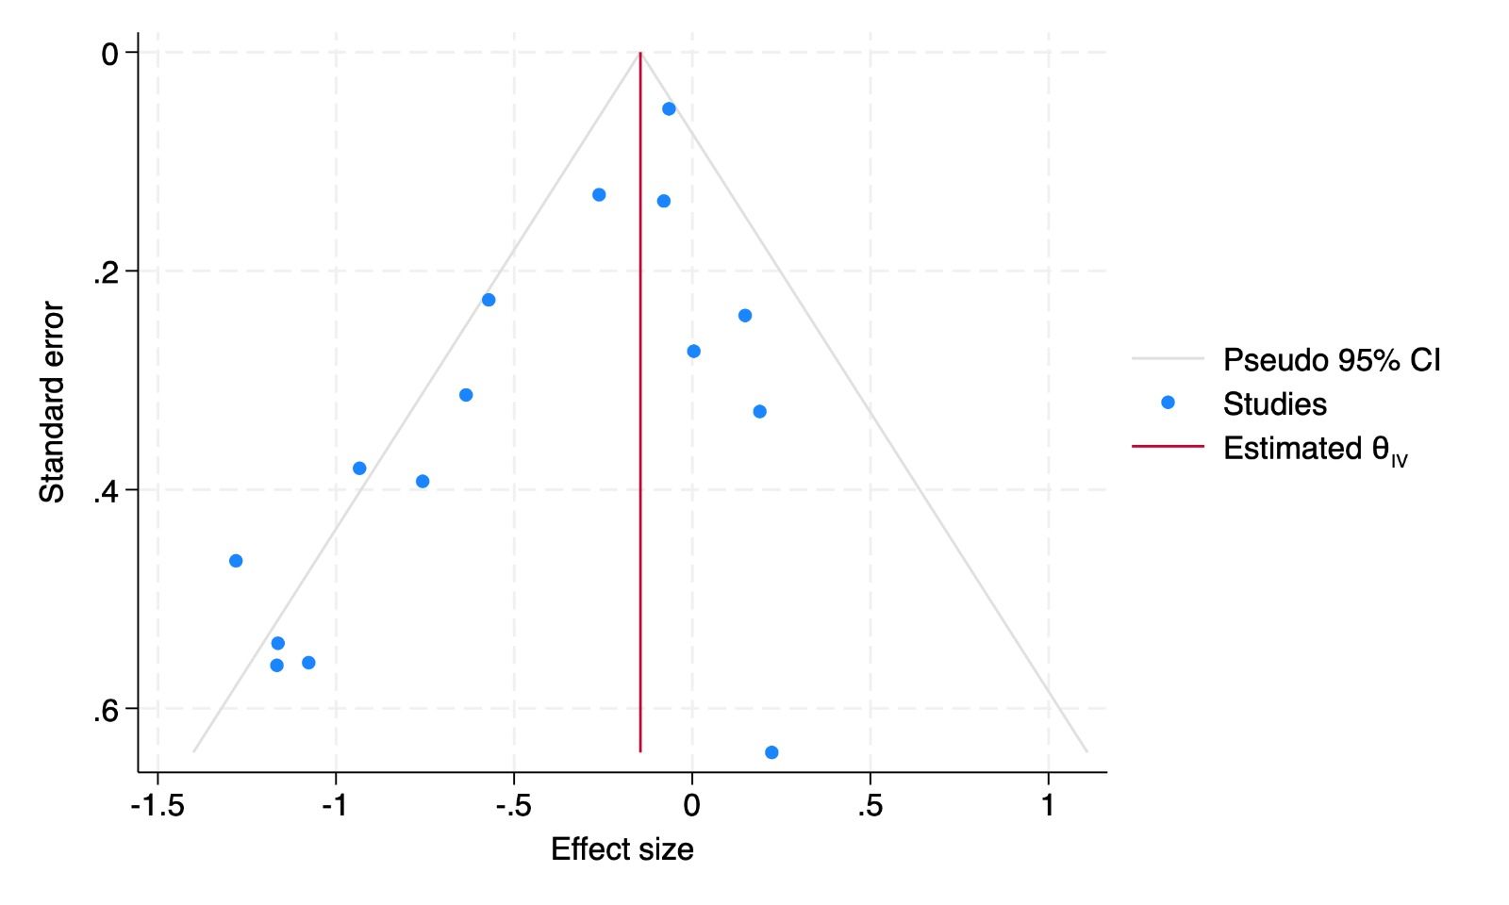
Figure S1. Funnel plot assessing publication bias for all randomised trials for suture types

Figure S2. Funnel plot assessing publication bias for by included low-quality and high-quality randomised trials for suture types

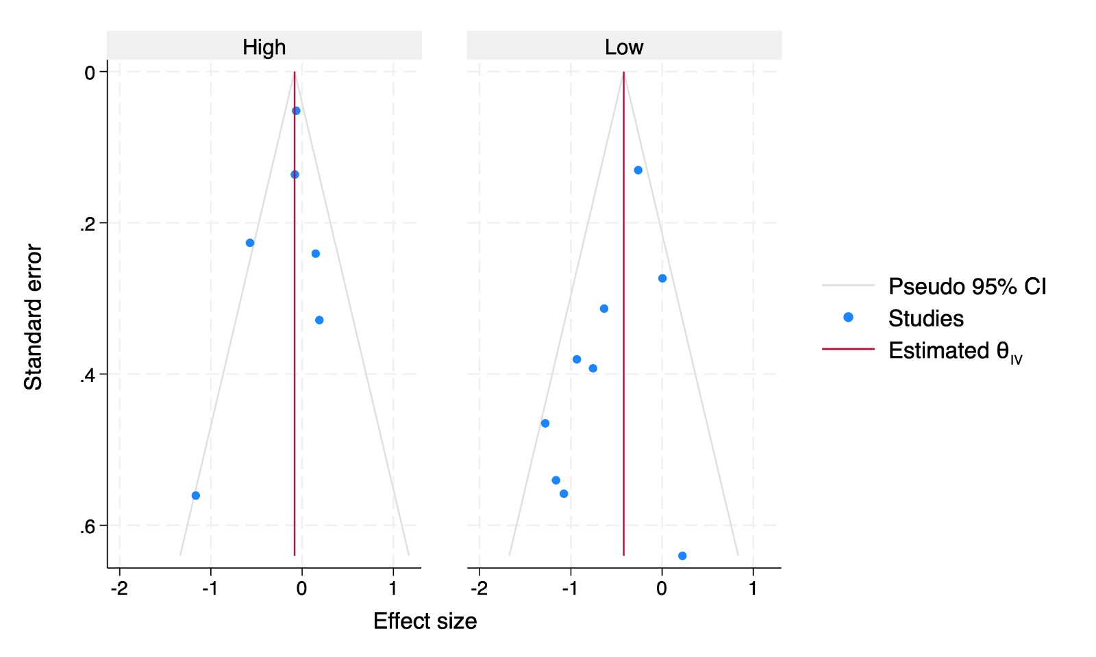

Figure S3. Simulations of an ongoing high-quality trial on overall meta-analysis findings including 500 patients in each arm (A) No effect (B) 10% reduction (C) 20% reduction (D) 30% reduction (E) 40% reduction

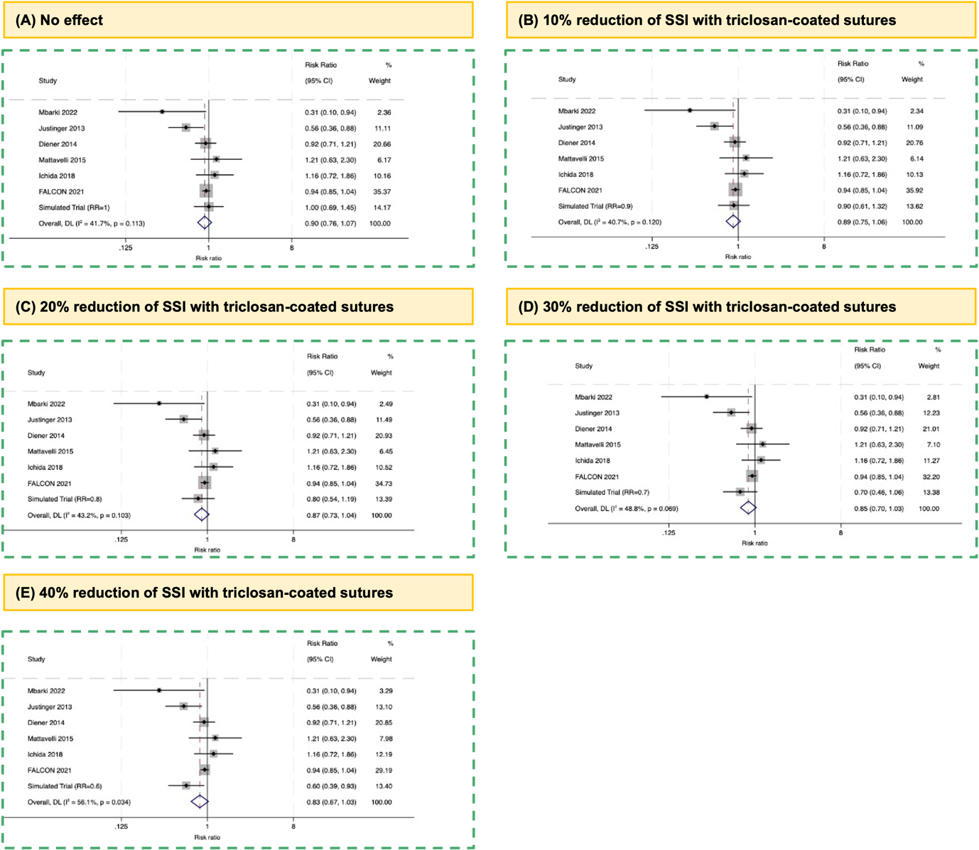

References

1. Chang WK, Srinivasa S, Morton R, Hill AG. Triclosan-impregnated sutures to decrease surgical site infections: systematic review and meta-analysis of randomized trials. Ann Surg 2012; 255(5): 854-9.

