Supplement

Surgical management of primary gynecomastia: outcomes of a peri-areolar round-block approach with absorbable barbed suture closure

Supplementary Figure S1. Age distribution of the study population.

Supplementary Figure S2. Aetiology of gynecomastia.

Supplementary Figure S3. Operative sequence including deepithelialisation and flap preservation.
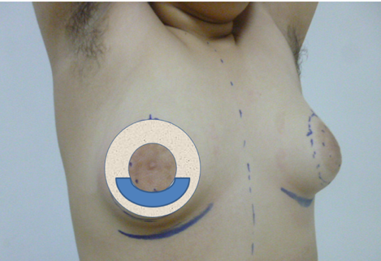

Supplementary Figure S4. Additional representative bilateral case outcomes. Source:
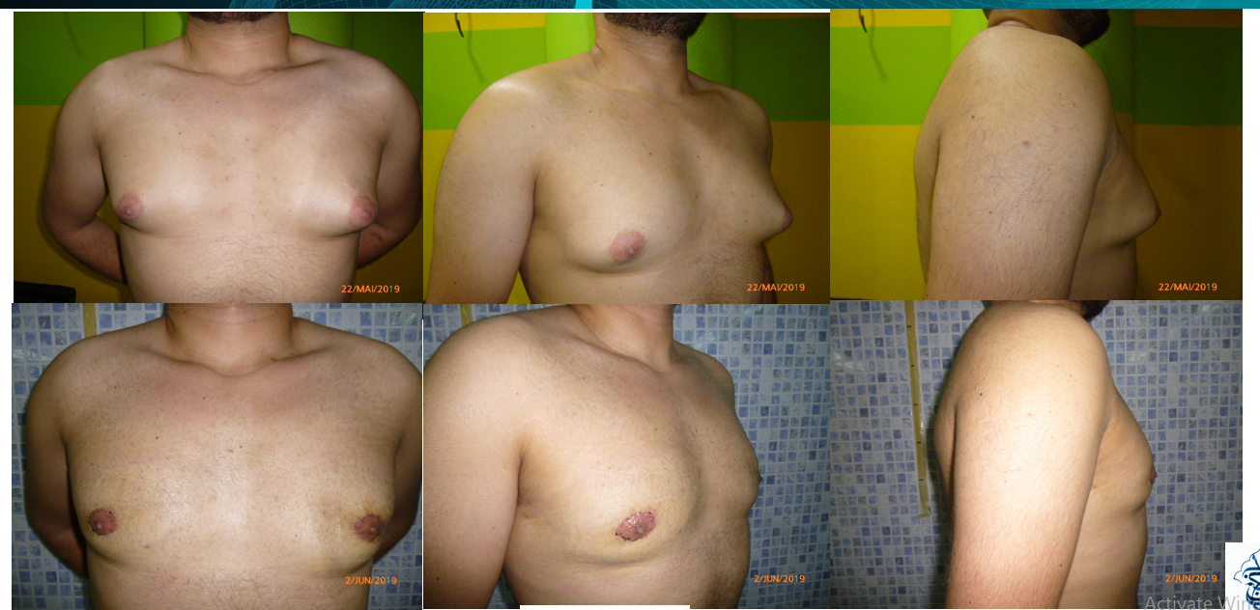
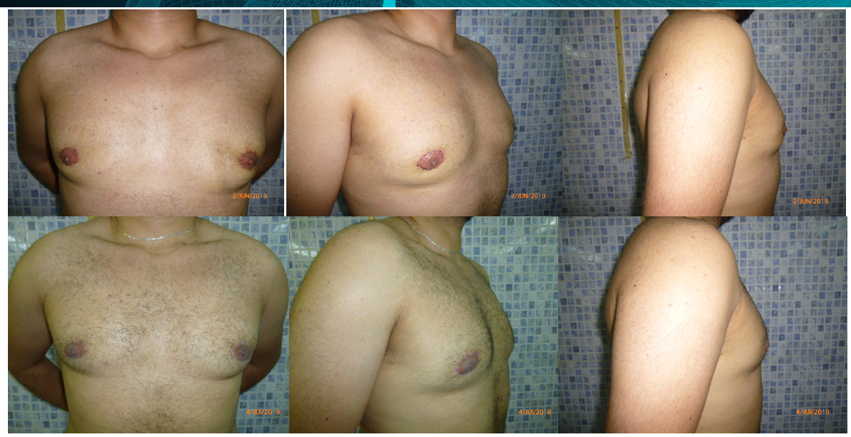

Supplementary Figure S5. Moderate to severe ptosis case example.
