Supplementary Appendix: Methods, assumptions, and reproducibility
National scenarios for soft-tissue robotic surgery in the NHS: a large-language model derived budget-impact modelling study
Correspondence: Professor Aneel Bhangu, Surgical Data Institute, Office 15/2nd Floor, Institute of Translational Medicine, Department of Applied Health Sciences, University of Birmingham, UK. Email: a.a.bhangu@bham.ac.uk

S1. Scope, versioning, and provenance
Objective. To provide a transparent, reproducible account of data sources, mappings, equations and computation used to estimate ten‑year cash costs and NHS budget shares under alternative adoption scenarios and platform mixes for soft‑tissue robotics in England.
Versioning. Methods reflect the final model run dated 14 September 2025. A change log is maintained in the code repository, tracking edits to mapping rules, MIS fractions, replacement logic and scenario parameters.
Provenance. Baseline caseloads are from Hospital Episode Statistics (HES) 2023–24 admitted‑care tables; minimally invasive (MIS) fractions are taken from UK national audits and guidance, with clearly flagged international analogues where required. Unit prices, capacities and installed base are stated in Section S6; budget denominators in Section S10.

S2. HES extraction workflow and data handling
Source table. HES admitted‑care workbook 2023–24, “Primary Procedure, 4‑character OPCS‑4”. The preamble rows were skipped so that columns read as: OPCS‑4 code; OPCS‑4 description; Finished Consultant Episodes (FCE). Rows were retained if the code matched the pattern A99.9 (uppercase letter, two digits, decimal point, single digit). FCE values were coerced to integers.
Family mapping. Each row was mapped to a clinically coherent soft‑tissue family spanning abdominal, pelvic, thoracic and selected transoral ENT procedures. Mapping used keyword rules validated against OPCS‑4 descriptions. Examples include cholecystectomy, anterior resection, lobectomy of lung and radical prostatectomy. Orthopaedics was excluded. Endoscopic retrograde procedures and caesarean hysterectomy were excluded on clinical grounds.
Appendicectomy correction. The primary four‑character table undercounts emergency appendicectomy. We applied a documented family‑level override setting minimally invasive appendicectomy to 45,000 cases per year, allocated across included appendix codes in proportion to observed FCE in 2023–24; the override is carried into the family roll‑up and flagged.
Aggregation order. MIS estimation was performed at code level where a family MIS fraction applied, then aggregated to family totals using FCE‑weighted means to preserve composition. The family roll‑up reports Total FCE, the weighted MIS percentage and estimated MIS cases per family.
Limitations. HES aggregates are robust for counting but do not encode approach at national‑table level; translating external MIS fractions onto HES totals assumes that case‑mix within a family does not materially bias the approach share. MIS fractions from audits lag by 12–24 months and may not capture recent shifts; where European analogues were used (for example liver and selected ENT), we used conservative values and labelled them explicitly. Trust‑level HES extracts remain the gold standard for business cases.

S3. Expanded soft‑tissue procedure families
Cholecystectomy; appendicectomy; abdominal wall hernia repair including inguinal, femoral, umbilical and incisional hernia; bariatric procedures including sleeve gastrectomy, gastric bypass and gastric banding; anti‑reflux and hiatus hernia surgery; colon resections including hemicolectomy and sigmoidectomy; rectal resections including anterior resection, abdominoperineal excision, Hartmann procedure and proctectomy; oesophagectomy and gastrectomy; liver resections including segmentectomy and hepatectomy; pancreatic resections including distal pancreatectomy and pancreaticoduodenectomy; lung resections including lobectomy and segmentectomy; thymectomy; radical prostatectomy; radical cystectomy; partial and radical nephrectomy; pyeloplasty; adrenalectomy; hysterectomy; oophorectomy and salpingo‑oophorectomy; ectopic pregnancy surgery including salpingectomy or salpingostomy; small‑bowel resections of jejunum and ileum; and defined transoral ENT and oral resections suitable for TORS (for example partial glossectomy, base of tongue, oropharyngeal resections, supraglottic and partial laryngectomy, pharyngectomy).

S4. MIS fractions and sources
MIS fractions were assigned at family level from UK national audits and guidance. Cholecystectomy is predominantly laparoscopic in day‑case settings; appendicectomy is mostly laparoscopic in national pathways; laparoscopy for inguinal hernia shows marked variation and lower national adoption; bariatric surgery is almost universally MIS in contemporary NHS practice. For major cancer resections, colorectal MIS is widely adopted but heterogeneous; oesophagectomy and gastrectomy have lower national MIS prevalence and include hybrid and fully minimally invasive approaches; radical prostatectomy is largely robotic in England. Numerical fractions by family and citations are given in Supplementary Table S1. Pancreatic resections were set at 10% MIS at baseline.
Evidence hierarchy. Where several sources existed we preferred UK national audits, then UK specialty registries, then UK guidance and commissioning documents, and finally recent European registries or large multicentre datasets. Where families spanned related OPCS‑4 codes, MIS percentages were applied at code level and aggregated to families by FCE‑weighted means. Procedure families and MIS fractions (assignment approach with sources)
- Colorectal cancer resections. The MIS fraction was taken from the National Bowel Cancer Audit State of the Nation series and applied to mapped colorectal resection OPCS-4 codes [1].
- Oesophago-gastric resections. MIS included both fully minimally invasive and hybrid approaches, aligned to NICE IPG 407 and NOGCA methodology. Current rates and the hybrid versus fully minimally invasive split were taken from NOGCA reports and methods papers [2,3,14].
- Radical prostatectomy. The MIS fraction was taken from BAUS national figures and corroborated with the National Prostate Cancer Audit; robotic assistance is dominant in England [4,5].
- Renal surgery. MIS shares for partial and radical nephrectomy were taken from BAUS national reporting where laparoscopic and robotic approaches are summarised by operation type, aggregated as MIS for the kidney families [4].
- Lung resections. Thoracoscopic MIS fractions were drawn from the National Lung Cancer Audit and corroborated with Society for Cardiothoracic Surgery materials; nationally benchmarked VATS adoption levels were used for lobectomy and segmentectomy [6].
- Cholecystectomy. Day-case laparoscopic dominance is supported by BADS guidance and GIRFT day-case implementation materials; a high MIS fraction was applied accordingly [7,8].
- Appendicectomy. The MIS fraction was anchored to UK best-practice guidance from GIRFT and partner Royal Colleges, which recommend laparoscopy as the usual approach; this was translated into a high national MIS percentage for the mapped appendicectomy codes [9].
- Inguinal and abdominal wall hernia repair. The MIS fraction was taken from NICE TA83 and a national BJS Open analysis that quantified hospital-level variation in laparoscopic use; that national share was applied to mapped hernia codes with known geographic variation noted [10,11].
- Bariatric surgery. MIS was treated as near-universal for primary procedures based on the NHS National Obesity Audit and BOMSS reporting; this was applied to mapped bariatric codes [12].
- Hysterectomy. MIS fractions were taken from English HES-based cohort work documenting the shift from open to minimal access and corroborated by wider evidence syntheses; values were applied to mapped hysterectomy codes by indication where available (full citations listed in Supplementary Table S1) [15].
- Liver resections. Where a single UK national MIS percentage by approach was not available, conservative fractions were informed by high-quality European registry analyses and large multicentre cohorts and flagged as “international analogue” in the working table (citations in Supplementary Table S1) [15].
- Pancreatic resections. A conservative MIS fraction was set for distal pancreatectomy and pancreaticoduodenectomy in line with contemporary UK adoption levels reported in national series and guideline context (citations in Supplementary Table S1) [15].
- ENT and oral cavity (TORS subset). Inclusion and cautious MIS fractions for robot-capable transoral resections were informed by NHS England policy and implementation guidance, supplemented by UK unit-level series; these map to transoral or robot-specific OPCS-4 codes where applicable [13,15].

S5. Scenario definitions and platform mixes
Adoption targets were 30%, 50% and 90% of the MIS pool delivered robotically by the end of Year 5. Adoption was ramped linearly across Years 1–5 and held through Years 6–10. Platform mixes were: Full (Type‑A only for all families); Mixed (Types A and B at 60% and 40% for both major and simple lists); and Hybrid (A and B at 60% and 40% for major resections and, for simple lists, Types A, B and C at 10%, 10% and 80%). The major versus simple split was fixed a priori to preserve A/B capacity for complex resections while allowing lower‑cost platforms to scale on high‑volume simple lists.

S6. Unit prices, capacities, installed base and budget denominator
Capital prices were £1,800,000 for Type‑A, £1,200,000 for Type‑B and £250,000 for Type‑C. Per‑case consumables were £2,000, £1,500 and £250 for Types A, B and C. Throughputs at maturity were 250 cases per year for Types A and B and 350 for Type C. The installed base at model start was credited as 140 soft‑tissue platforms with an 80:20 A:B split (A 112, B 28, C 0). The NHS budget denominator was set at £192 billion in Year 1 with 2% nominal growth per year; the same series was applied across scenarios so shares are comparable.

S7. Formal model definitions
Index procedures by i and years by y∈{1,…,10}. Let annual volume be V_i and the MIS fraction m_i. The MIS pool is V_i m_i. For a target robotic share t∈{0.30,0.50,0.90} and a linear ramp to Year 5, the robotic share is r_y = t·(y/5) for 1≤y≤5, and r_y = t for 6≤y≤10. Robotic cases are R_i,y = V_i m_i r_y.
Define platform mixes for major procedures α^maj = (α_A, α_B, α_C) and for simple procedures β^sim = (β_A, β_B, β_C), each summing to one. Aggregate robotic cases by platform: R_p,y = Σ_{i∈major} R_i,y α_p^{maj} + Σ_{i∈simple} R_i,y β_p^{sim}, for p∈{A,B,C}.
With capacities k_A=250, k_B=250 and k_C=350 cases per year, the required in‑service fleet is F_p,y = ceil(R_p,y / k_p).
Installed base is B_A^{inst}=112, B_B^{inst}=28, B_C^{inst}=0. Purchases follow a non‑accumulating replacement rule. In Year 1: Buy_p,1 = max(0, F_p,1 − B_p^{inst}). In Years 2–5: Buy_p,y = max(0, F_p,y − F_p,y−1) to top‑up any increase in requirement. In Years 6–10: Buy_p,y = max(0, F_p,y − F_p,y−1) + floor(ρ · F_p,y), where ρ is the annual replacement rate (base 0.04). On‑fleet is set to the requirement each year, OnFleet_p,y = F_p,y, so replacement is a like‑for‑like swap and does not inflate the fleet.
Capital prices are C_A^{cap}=£1,800,000, C_B^{cap}=£1,200,000, C_C^{cap}=£250,000. Per‑case consumables are C_A^{use}=£2,000, C_B^{use}=£1,500, C_C^{use}=£250. Annual capital and consumable costs are Capex_y = Σ_p Buy_p,y C_p^{cap} and Consum_y = Σ_p R_p,y C_p^{use}. Total programme cost is Cost_y = Capex_y + Consum_y.
Let H_y be the NHS budget in year y with H_1 = £192 billion and H_y = H_1 × 1.02^{(y−1)}. Share of budget is S_y = 100 × Cost_y / H_y (per cent).

S8. Computation, quality assurance, and outputs
Implementation. Python was used for all computations (pandas for tabulation, numpy for arithmetic). Rounding rules: fleets are computed with ceiling to the next integer; replacement uses floor; cash totals are reported to the nearest £0.1 million in tables and to £0.001 billion in plots. Smoothing: plots use a cubic spline of order three across Years 1–10 for presentation only; reported values are the discrete annual outputs.
Quality assurance. Unit tests checked that (i) the appendicectomy override yields 45,000 MIS cases in total; (ii) fleet counts do not grow in Years 6–10 under constant requirement; (iii) percentage‑of‑budget figures equal cash totals divided by the correct denominator series; (iv) replacement capex equals floor(ρ · F_p,y) × C_p^{cap} in Years 6–10. Scenario parity checks ensured ordering by adoption level and by platform mix.
Outputs. For each scenario–mix pair the workbook exports: allocations by family and platform (Years 1–10); platform‑level case totals by year; fleet purchases and on‑fleet counts by year; and costs (capex, consumables, totals, budget shares) by year. An index sheet records parameters, installed base and the budget series.

S9. Sensitivity analyses
Replacement rate. Rolling replacement increased from 4% to 10% and 20% per year in Years 6–10, applied as like‑for‑like swaps against the requirement to avoid compounding fleet size. Throughput. A conservative A‑class throughput of 200 cases per year was tested with B and C unchanged. All other parameters remained as in the base model.

S10. NHS budget comparison: denominators, sources and harmonisation
Comparators. Department of Health and Social Care (DHSC) group outturn totals for 2023/24 are used for external comparators: resource DEL £183.9 billion, capital DEL £11.0 billion; Total DEL (TDEL) £188.6 billion. Each comparator line is expressed as a share of £188.6 billion. Robotic scenarios use the model’s own NHS cash series beginning at £192 billion with 2% nominal growth; Year‑5 cash is used to translate Year‑5 model percentages into £ billion. Because comparators and scenarios use different denominators and years, percentages are read as indicators of scale. A harmonised restatement to a single denominator (either 2023/24 TDEL or the model’s Year‑5 cash) is available on request; the rank ordering is unchanged. Comparator data sources and treatment. Consolidated NHS provider accounts supply the hospital cost lines. We use the published totals for staff costs, medicines, premises, and clinical supplies. The medicines line is split into hospital medicines from provider accounts and community prescriptions from the NHSBSA Prescription Cost Analysis (PCA) for 2023/24. PCA is reported as Net Ingredient Cost and is a standard, widely used series for scaling, but it does not equal actual outturn spend; we retain it as published and flag this in the table notes. The Cancer Drugs Fund (CDF) and Innovative Medicines Fund (IMF) are taken from NHS England finance papers and Parliamentary statements for 2023/24. Regulator lines are taken from the relevant arm’s length bodies’ annual reports and accounts for 2023/24, using net expenditure for CQC and NICE. For wider context we cite independent syntheses that explain the DHSC accounting framework and confirm the order of magnitude for TDEL. All values are recorded in cash terms. Where a source reports a range or an in-year adjustment, we select the most authoritative year-end figure and record the source and basis in the data file.

S11. Data governance, privacy and security
Only aggregate HES tables and published audit statistics were used. No patient‑level, identifiable or confidential data were processed. Working files contain only code‑level mappings, family totals and scenario outputs. Reproducibility materials (prompts, parameter sheets and scripts) are time‑stamped and archived.
Reproducibility prompts
Data inputs comprise the HES 2023–24 primary procedure four-character table and a table of MIS fractions by family with citations. The workflow is: map HES rows to families; exclude non-eligible procedures; apply MIS fractions at code level; aggregate to families; fix the appendicectomy undercount with the documented override; split families into major and simple; select adoption target and platform mix; apply capacities and the installed base; compute fleet requirements and purchases including replacement from Year 6; price capital and consumables; sum to annual cash and compute budget shares; export scenario tables and figures. All rounding rules are given above. Random seeds are not applicable. No patient-level data were used.

S12. Assumptions and limitations
Installed base counts and mix approximate current soft‑tissue inventories and should be replaced by trust‑verified lists. Throughput assumes stable list productivity and will vary with theatre access and scheduling. Consumable prices are held flat in cash terms; contracting, tray design and re‑use policies can change per‑case costs. Maintenance, service contracts, estates works and financing method are not included. Clinical consequences and offsets are not priced. The four‑character HES table undercounts emergency appendicectomy; the documented override improves but does not replace a full extract including secondary procedures. MIS fractions vary geographically and over time; local analyses should substitute current trust or ICS series.

S13. Supplementary Table S1
Family‑level MIS fractions, numerical values and full source list for each mapped OPCS‑4 code family. The table records, for each family: included OPCS‑4 descriptions; Total FCE; MIS percentage; estimated MIS cases; primary citation; and any notes on international analogues or exclusions.

S14. Methods for laparoscopy offset sensitivity analysis

This supplementary sensitivity analysis quantifies the incremental NHS cash cost of introducing robotic surgery relative to continued laparoscopic provision. It layers a laparoscopic counterfactual onto the national budget model to show annual and cumulative incremental spend, percentage of NHS budget, and incremental cost per robotic case. Two baselines are reported: a ‘no‑credit’ baseline that leaves laparoscopic replacement and maintenance unchanged, and a ‘utilisation‑adjusted’ baseline that reduces laparoscopic replacement and maintenance in proportion to the share of minimally invasive surgery displaced by robotics (discounted by 0.2 to allow for conversions from open).

Methods
Design. We extend the national budget model by adding a laparoscopic counterfactual. Costs are reported in cash terms over ten years without discounting, aligned to NHS cash budgeting practices.
Activity. The annual pool of minimally invasive procedures is fixed at 196,240 cases. Robotic adoption ramps linearly to the scenario target by Year 5 and remains steady thereafter. Robotic cases displace laparoscopy for 80% of activity, with the remaining 20% assumed to be conversions from open surgery.
Robotic costs. For each scenario, capital outlays are spread evenly across Years 1–5; rolling replacement is spread across Years 6–10; consumables ramp to a steady‑state annual level by Year 5. Scenario totals (capex, replacement, consumables, steady‑state cases) match the manuscript waypoints.
Laparoscopic counterfactual. The installed laparoscopy base is sized to cover the MIS pool at a planning capacity of 325 cases per stack per year. The ‘no‑credit’ baseline assumes ongoing lap replacement and maintenance continue unchanged. The utilisation‑adjusted baseline credits avoided lap consumables and scales down replacement and maintenance by the fraction of MIS displaced by robotics (cases_y / 196,240 × 0.8).
Incremental outcomes. Annual incremental spend Δ_y compares robotic spend to avoided lap costs under each baseline. We report Year‑5 and Year‑10 point estimates, 10‑year cumulative totals, percentage of NHS budget, and incremental cost per case.

Assumptions
Laparoscopy: £500 per case for consumables; 10% annual replacement of the installed base; £200,000 per stack; £10,000 annual maintenance per stack; capacity 325 cases/stack/year. Robotic: scenario totals from the manuscript (30% Hybrid: capex £37m, replacement £49m (Years 6–10), consumables steady‑state £44m/year; 50% Mixed: £378m, £125m, £177m; 90% Full: £1,071m, £278m, £353m). NHS cash budget begins at £192bn with 2% nominal growth.
Supplementary Table A. Planning parameters and costs.
Parameter | Assumed value
MIS baseline activity (cases/year) | 196,240
Robotic displacement from laparoscopy | 80% (20% from open)
Laparoscopic consumables per case | £500
Laparoscopic stack capacity | 325 cases/year
Laparoscopic stack price (capital) | £200,000
Annual lap replacement rate | 10% of installed base
Annual lap maintenance per stack | £10,000
Installed lap base (derived) | 604 stacks
NHS budget Year 1 | £192bn (2% growth)

Table B summarises Year‑5 and Year‑10 incremental outcomes and 10‑year cumulative totals under both baselines. Results are consistent with the modelled ramp and steady‑state profiles.

Supplementary Table B. Headline incremental results (Δ vs laparoscopy). Values in £bn unless stated.
Scenario | Y5_Delta_no_credit | Y5_Delta_no_credit_%Budget | Y5_Delta_util_adj | Y5_Delta_util_adj_%Budget | Y10_Delta_no_credit | Y10_Delta_no_credit_%Budget | Y10_Delta_util_adj | Y10_Delta_util_adj_%Budget | Cum10_Delta_no_credit | Cum10_Delta_util_adj | Y5_Inc_per_case_no_credit | Y5_Inc_per_case_util_adj | Y10_Inc_per_case_no_credit | Y10_Inc_per_case_util_adj
30% Hybrid | 0.028 | 0.01% | 0.024 | 0.01% | 0.030 | 0.01% | 0.026 | 0.01% | 0.250 | 0.215 | £473 | £399 | £514 | £440
50% Mixed | 0.213 | 0.10% | 0.206 | 0.10% | 0.163 | 0.07% | 0.156 | 0.07% | 1.605 | 1.547 | £2,174 | £2,101 | £1,659 | £1,585
90% Full | 0.497 | 0.24% | 0.484 | 0.23% | 0.338 | 0.15% | 0.325 | 0.14% | 3.608 | 3.503 | £2,811 | £2,738 | £1,913 | £1,840

Supplementary Table C. Year‑by‑year incremental outcomes (utilisation‑adjusted baseline). Values in £bn unless stated.
Scenario | Year | Robotic_spend_total | Avoided_lap_consumables | Lap_capex_credit_util | Lap_maint_credit_util | Delta_util_adj | Delta_util_adj_%Budget | Inc_per_case_util_adj | Robotic_cases
30% Hybrid | 1 | 0.016 | 0.005 | 0.001 | 0.000 | 0.011 | 0.01% | £902 | 11,774
30% Hybrid | 2 | 0.025 | 0.009 | 0.001 | 0.001 | 0.014 | 0.01% | £588 | 23,549
30% Hybrid | 3 | 0.034 | 0.014 | 0.002 | 0.001 | 0.017 | 0.01% | £483 | 35,323
30% Hybrid | 4 | 0.043 | 0.019 | 0.002 | 0.001 | 0.020 | 0.01% | £431 | 47,098
30% Hybrid | 5 | 0.051 | 0.024 | 0.003 | 0.001 | 0.024 | 0.01% | £399 | 58,872
30% Hybrid | 6 | 0.054 | 0.024 | 0.003 | 0.001 | 0.026 | 0.01% | £440 | 58,872
30% Hybrid | 7 | 0.054 | 0.024 | 0.003 | 0.001 | 0.026 | 0.01% | £440 | 58,872
30% Hybrid | 8 | 0.054 | 0.024 | 0.003 | 0.001 | 0.026 | 0.01% | £440 | 58,872
30% Hybrid | 9 | 0.054 | 0.024 | 0.003 | 0.001 | 0.026 | 0.01% | £440 | 58,872
30% Hybrid | 10 | 0.054 | 0.024 | 0.003 | 0.001 | 0.026 | 0.01% | £440 | 58,872
50% Mixed | 1 | 0.111 | 0.008 | 0.001 | 0.000 | 0.102 | 0.05% | £5,182 | 19,624
50% Mixed | 2 | 0.146 | 0.016 | 0.002 | 0.001 | 0.128 | 0.07% | £3,256 | 39,248
50% Mixed | 3 | 0.182 | 0.024 | 0.003 | 0.001 | 0.154 | 0.08% | £2,614 | 58,872
50% Mixed | 4 | 0.217 | 0.031 | 0.004 | 0.002 | 0.180 | 0.09% | £2,293 | 78,496
50% Mixed | 5 | 0.253 | 0.039 | 0.005 | 0.002 | 0.206 | 0.10% | £2,101 | 98,120
50% Mixed | 6 | 0.202 | 0.039 | 0.005 | 0.002 | 0.156 | 0.07% | £1,585 | 98,120
50% Mixed | 7 | 0.202 | 0.039 | 0.005 | 0.002 | 0.156 | 0.07% | £1,585 | 98,120
50% Mixed | 8 | 0.202 | 0.039 | 0.005 | 0.002 | 0.156 | 0.07% | £1,585 | 98,120
50% Mixed | 9 | 0.202 | 0.039 | 0.005 | 0.002 | 0.156 | 0.07% | £1,585 | 98,120
50% Mixed | 10 | 0.202 | 0.039 | 0.005 | 0.002 | 0.156 | 0.07% | £1,585 | 98,120
90% Full | 1 | 0.285 | 0.014 | 0.002 | 0.001 | 0.268 | 0.14% | £7,589 | 35,323
90% Full | 2 | 0.355 | 0.028 | 0.003 | 0.002 | 0.322 | 0.16% | £4,557 | 70,646
90% Full | 3 | 0.426 | 0.042 | 0.005 | 0.003 | 0.376 | 0.19% | £3,546 | 105,970
90% Full | 4 | 0.497 | 0.057 | 0.007 | 0.003 | 0.430 | 0.21% | £3,041 | 141,293
90% Full | 5 | 0.567 | 0.071 | 0.009 | 0.004 | 0.484 | 0.23% | £2,738 | 176,616
90% Full | 6 | 0.409 | 0.071 | 0.009 | 0.004 | 0.325 | 0.15% | £1,840 | 176,616
90% Full | 7 | 0.409 | 0.071 | 0.009 | 0.004 | 0.325 | 0.15% | £1,840 | 176,616
90% Full | 8 | 0.409 | 0.071 | 0.009 | 0.004 | 0.325 | 0.15% | £1,840 | 176,616
90% Full | 9 | 0.409 | 0.071 | 0.009 | 0.004 | 0.325 | 0.14% | £1,840 | 176,616
90% Full | 10 | 0.409 | 0.071 | 0.009 | 0.004 | 0.325 | 0.14% | £1,840 | 176,616

Supplementary Figure A. Annual incremental spend vs laparoscopy.
Solid lines show ‘no‑credit’ (laparoscopy costs unchanged); dashed lines show ‘utilisation‑adjusted’ (laparoscopy replacement and maintenance reduced in proportion to displaced MIS).
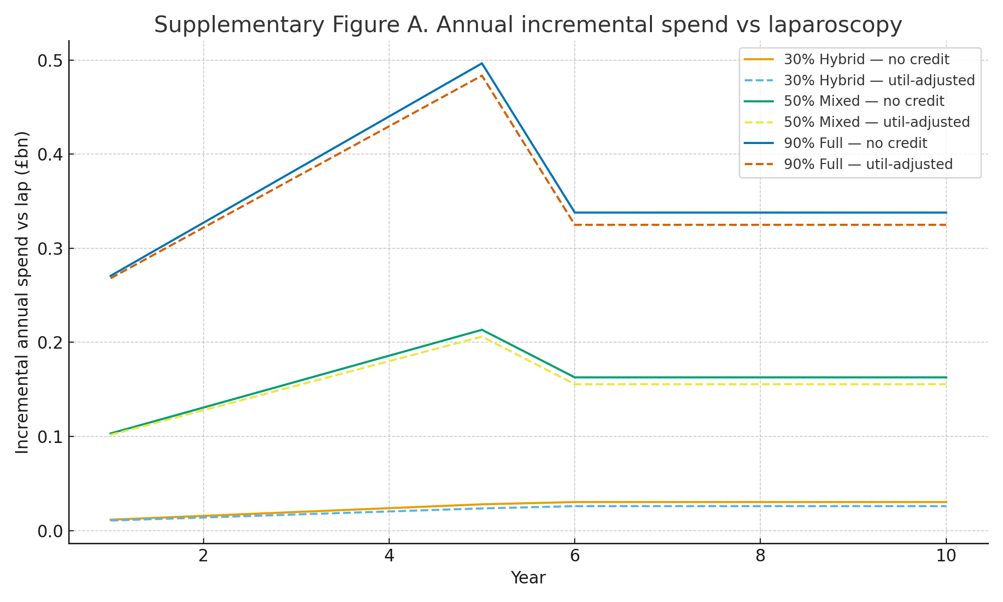
Supplementary Figure B. Cumulative incremental spend vs laparoscopy.
Cumulative totals over ten years for both baselines; values correspond to the time‑integral of Figure A.
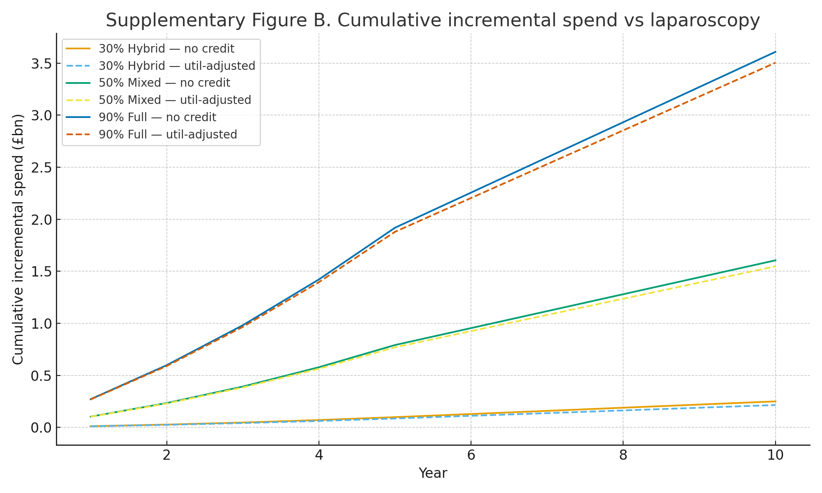

Supplementary Figure C. Incremental cost per robotic case (utilisation‑adjusted).
National planning metric at Years 5 and 10 by scenario; labels align with the steady‑state case volumes in the model.
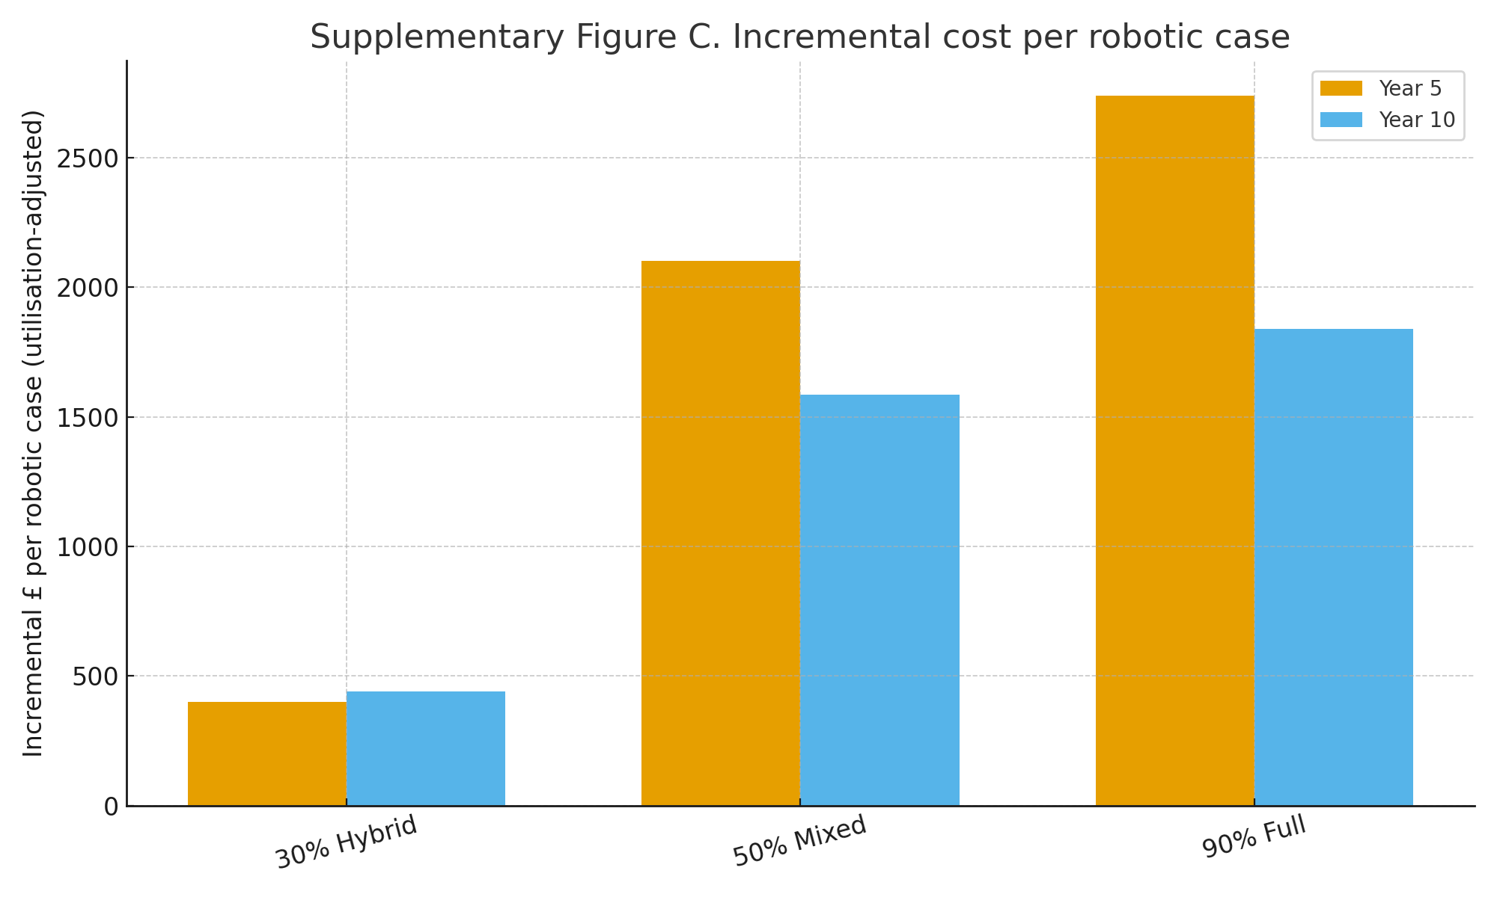
Supplementary Figure D1. Year‑5 waterfall (utilisation‑adjusted): 30% Hybrid.
Components of Year‑5 Δ: robotic spend minus avoided lap costs. Negative bars are savings relative to continued laparoscopy.
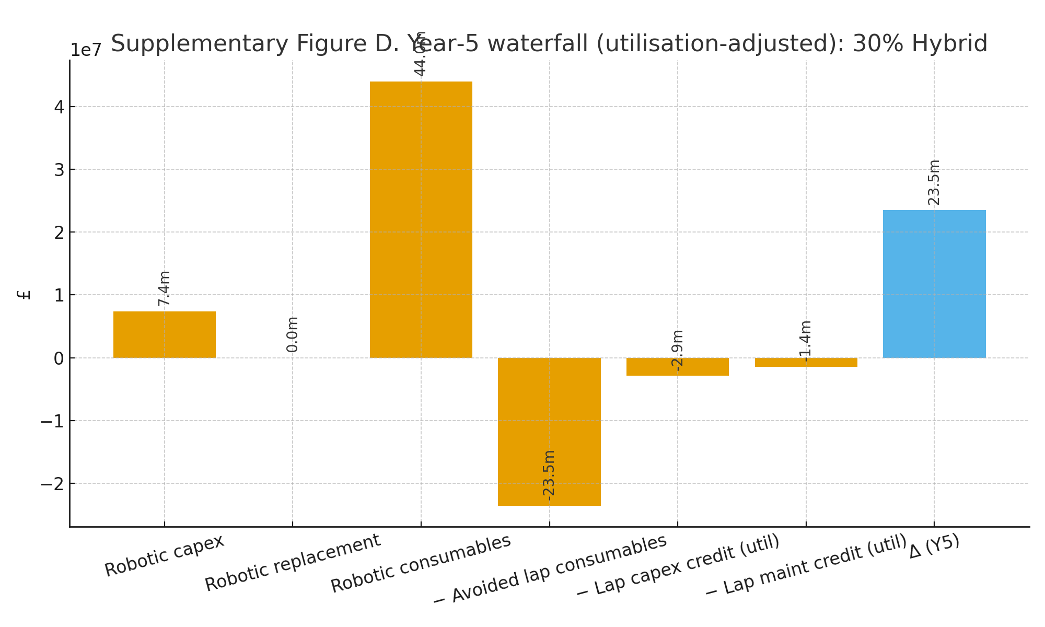

Supplementary Figure D2. Year‑5 waterfall (utilisation‑adjusted): 50% Mixed.
Same construction as D1; absolute values larger due to higher adoption and consumables.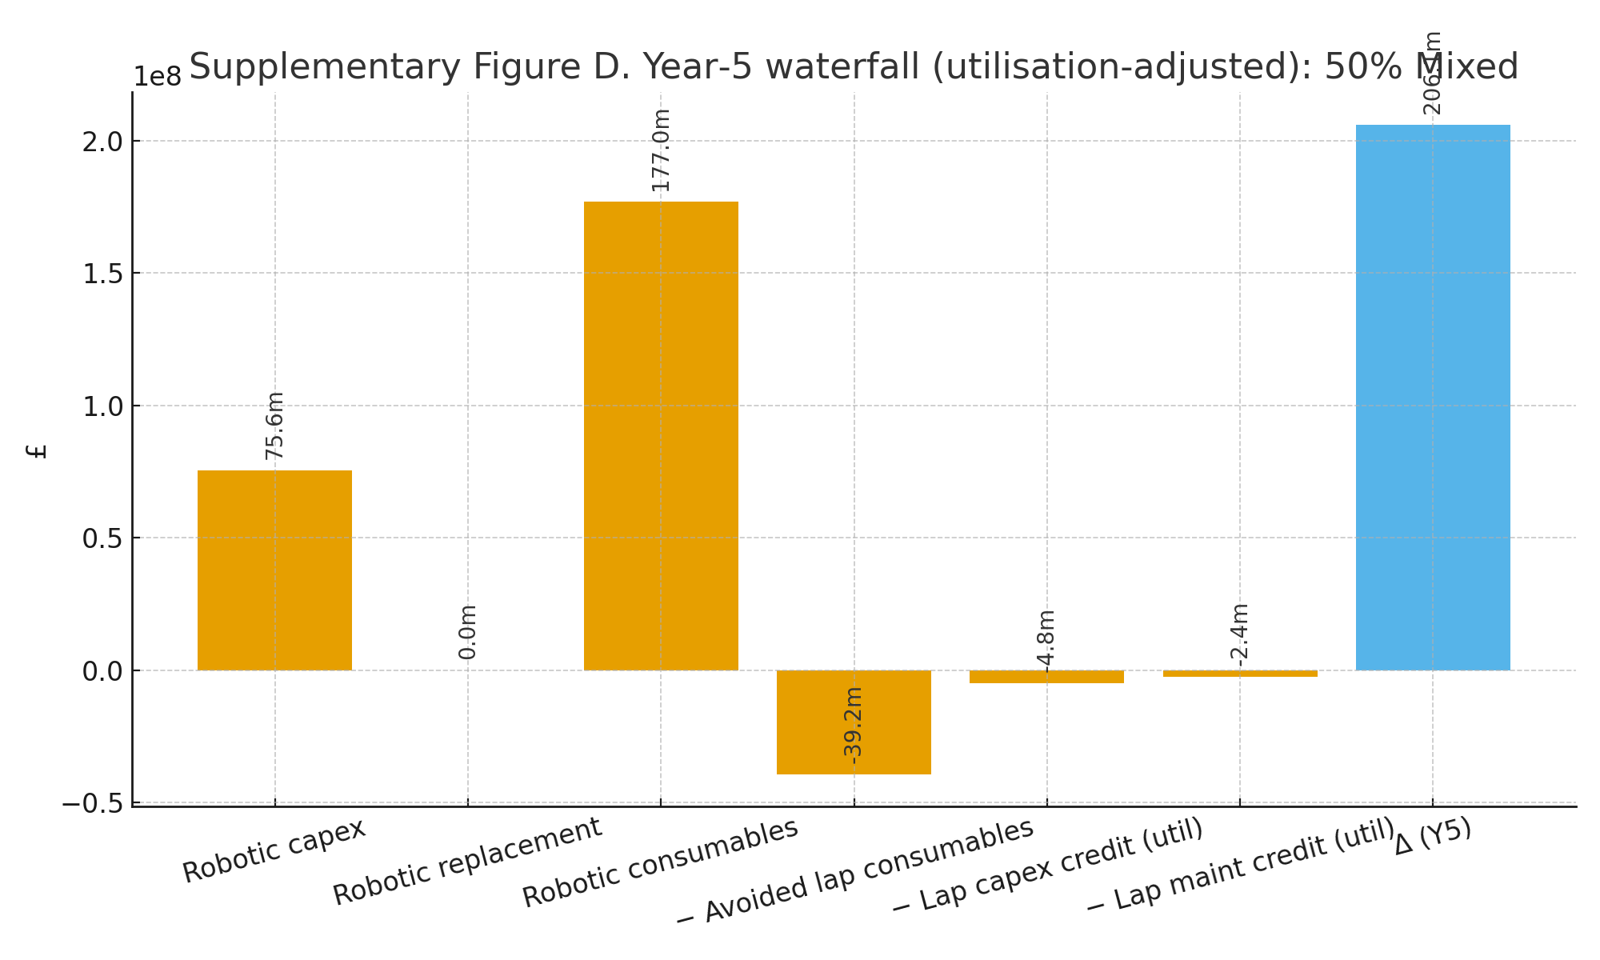
Supplementary Figure D3. Year‑5 waterfall (utilisation‑adjusted): 90% Full.
Largest early‑year envelope due to front‑loaded capex and higher steady‑state consumables; lap credits partially offset.
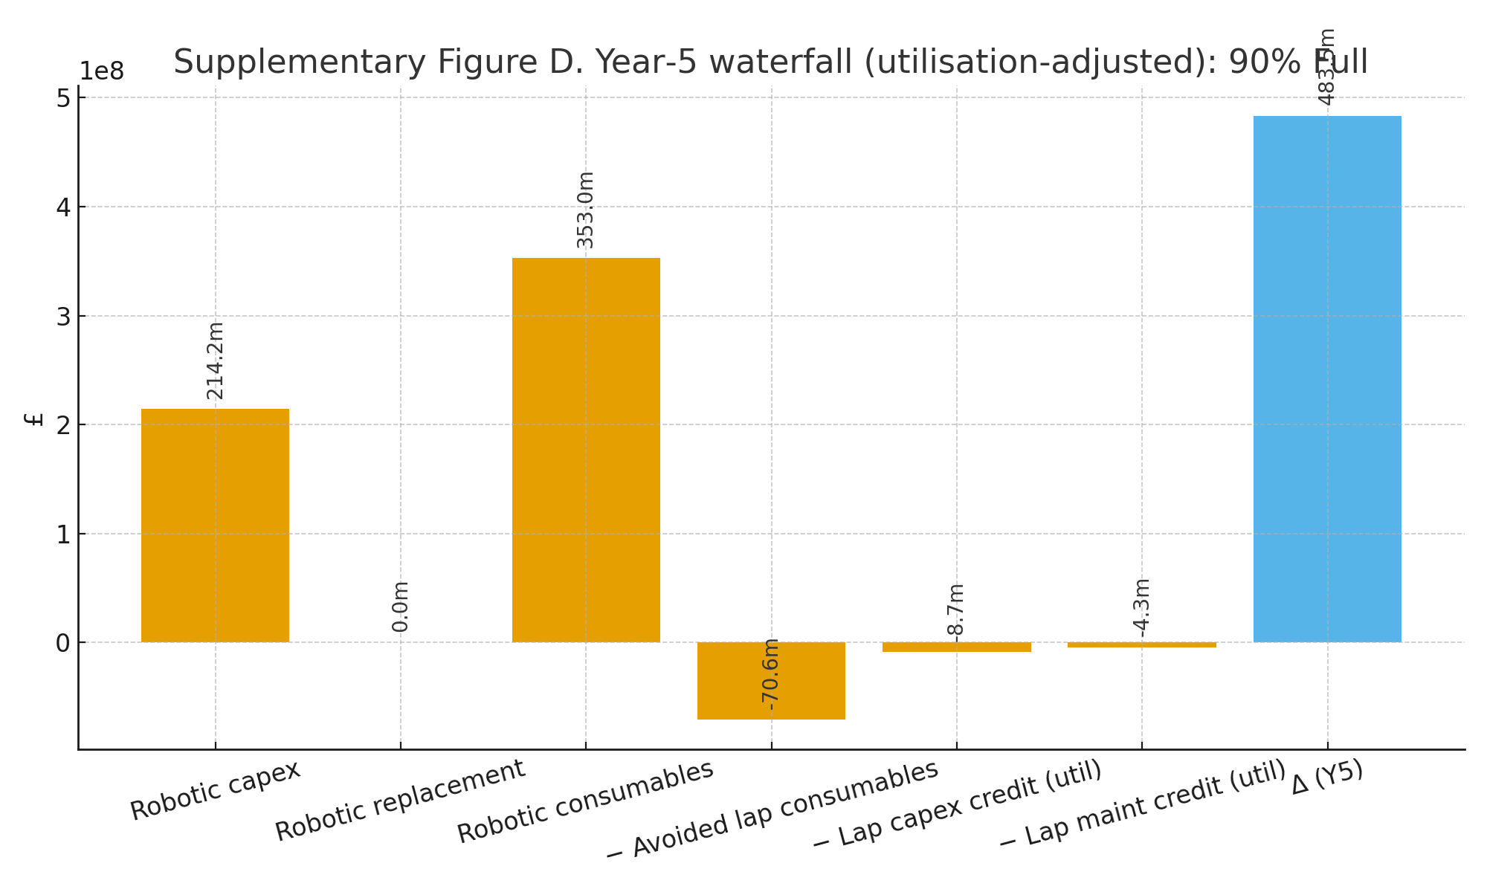

Supplementary Tables

Table S1. OPCS‑4 code to procedure family mapping and MIS estimates
Columns: Family; OPCS‑4 code; Description; Finished Consultant Episodes (FCE); MIS (%); Estimated MIS cases; Primary source (ref #).
Family | OPCS‑4 code | Description | FCE | MIS (%) | Estimated MIS cases
Adrenalectomy | B22.2 | Bilateral adrenalectomy NEC | 18 | 85.0 | 15.3
Adrenalectomy | B22.3 | Unilateral adrenalectomy | 926 | 85.0 | 787.1
Adrenalectomy | B22.4 | Partial adrenalectomy | 6 | 85.0 | 5.1
Appendicectomy | H01.8 | Other specified emergency excision of appendix | 26 | 90.0 | 136.2
Appendicectomy | H01.9 | Unspecified emergency excision of appendix | 1534 | 90.0 | 8038.0
Appendicectomy | H02.1 | Interval appendicectomy | 625 | 90.0 | 3274.9
Appendicectomy | H02.2 | Planned delayed appendicectomy NEC | 353 | 90.0 | 1849.7
Appendicectomy | H02.3 | Prophylactic appendicectomy NEC | 79 | 90.0 | 413.9
Appendicectomy | H02.4 | Incidental appendicectomy | 6 | 90.0 | 31.4
Appendicectomy | H02.8 | Other specified other excision of appendix | 177 | 90.0 | 927.5
Appendicectomy | H02.9 | Unspecified other excision of appendix | 5788 | 90.0 | 30328.4
Bariatric (sleeve/bypass/band) | G28.4 | Sleeve gastrectomy and duodenal switch | 14 | 98.0 | 13.7
Bariatric (sleeve/bypass/band) | G28.5 | Sleeve gastrectomy NEC | 2970 | 98.0 | 2910.6
Cholecystectomy | J18.1 | Total cholecystectomy and excision of surrounding tissue | 587 | 95.0 | 557.6
Cholecystectomy | J18.2 | Total cholecystectomy and exploration of common bile duct | 1095 | 95.0 | 1040.2
Cholecystectomy | J18.3 | Total cholecystectomy NEC | 65757 | 95.0 | 62469.2
Cholecystectomy | J18.4 | Partial cholecystectomy and exploration of common bile duct | 110 | 95.0 | 104.5
Cholecystectomy | J18.5 | Partial cholecystectomy NEC | 1887 | 95.0 | 1792.6
Colon resections (colectomy/hemicolectomy) | H05.1 | Total colectomy and anastomosis of ileum to rectum | 87 | 70.0 | 60.9
Colon resections (colectomy/hemicolectomy) | H05.2 | Total colectomy and ileostomy and creation of rectal fistula HFQ | 16 | 70.0 | 11.2
Colon resections (colectomy/hemicolectomy) | H05.3 | Total colectomy and ileostomy NEC | 414 | 70.0 | 289.8
Colon resections (colectomy/hemicolectomy) | H06.1 | Extended right hemicolectomy and end to end anastomosis | 173 | 70.0 | 121.1
Colon resections (colectomy/hemicolectomy) | H06.2 | Extended right hemicolectomy and anastomosis of ileum to colon | 1104 | 70.0 | 772.8
Colon resections (colectomy/hemicolectomy) | H06.3 | Extended right hemicolectomy and anastomosis NEC | 312 | 70.0 | 218.4
Colon resections (colectomy/hemicolectomy) | H06.4 | Extended right hemicolectomy and ileostomy HFQ | 333 | 70.0 | 233.1
Colon resections (colectomy/hemicolectomy) | H06.5 | Extended right hemicolectomy and end to side anastomosis | 35 | 70.0 | 24.5
Colon resections (colectomy/hemicolectomy) | H07.1 | Right hemicolectomy and end to end anastomosis of ileum to colon | 2341 | 70.0 | 1638.7
Colon resections (colectomy/hemicolectomy) | H07.2 | Right hemicolectomy and side to side anastomosis of ileum to transverse colon | 6527 | 70.0 | 4568.9
Colon resections (colectomy/hemicolectomy) | H07.3 | Right hemicolectomy and anastomosis NEC | 1855 | 70.0 | 1298.5
Colon resections (colectomy/hemicolectomy) | H07.4 | Right hemicolectomy and ileostomy HFQ | 1363 | 70.0 | 954.1
Colon resections (colectomy/hemicolectomy) | H07.5 | Right hemicolectomy and end to side anastomosis | 213 | 70.0 | 149.1
Colon resections (colectomy/hemicolectomy) | H08.1 | Transverse colectomy and end to end anastomosis | 92 | 70.0 | 64.4
Colon resections (colectomy/hemicolectomy) | H08.2 | Transverse colectomy and anastomosis of ileum to colon | 28 | 70.0 | 19.6
Colon resections (colectomy/hemicolectomy) | H08.3 | Transverse colectomy and anastomosis NEC | 64 | 70.0 | 44.8
Colon resections (colectomy/hemicolectomy) | H08.4 | Transverse colectomy and ileostomy HFQ | 30 | 70.0 | 21.0
Colon resections (colectomy/hemicolectomy) | H08.5 | Transverse colectomy and exteriorisation of bowel NEC | 54 | 70.0 | 37.8
Colon resections (colectomy/hemicolectomy) | H08.6 | Transverse colectomy and end to side anastomosis | 4 | 70.0 | 2.8
Colon resections (colectomy/hemicolectomy) | H09.1 | Left hemicolectomy and end to end anastomosis of colon to rectum | 198 | 70.0 | 138.6
Colon resections (colectomy/hemicolectomy) | H09.2 | Left hemicolectomy and end to end anastomosis of colon to colon | 405 | 70.0 | 283.5
Colon resections (colectomy/hemicolectomy) | H09.3 | Left hemicolectomy and anastomosis NEC | 377 | 70.0 | 263.9
Colon resections (colectomy/hemicolectomy) | H09.4 | Left hemicolectomy and ileostomy HFQ | 85 | 70.0 | 59.5
Colon resections (colectomy/hemicolectomy) | H09.5 | Left hemicolectomy and exteriorisation of bowel NEC | 365 | 70.0 | 255.5
Colon resections (colectomy/hemicolectomy) | H09.6 | Left hemicolectomy and end to side anastomosis | 44 | 70.0 | 30.8
Colon resections (colectomy/hemicolectomy) | H10.1 | Sigmoid colectomy and end to end anastomosis of ileum to rectum | 245 | 70.0 | 171.5
Colon resections (colectomy/hemicolectomy) | H10.2 | Sigmoid colectomy and anastomosis of colon to rectum | 760 | 70.0 | 532.0
Colon resections (colectomy/hemicolectomy) | H10.3 | Sigmoid colectomy and anastomosis NEC | 428 | 70.0 | 299.6
Colon resections (colectomy/hemicolectomy) | H10.4 | Sigmoid colectomy and ileostomy HFQ | 172 | 70.0 | 120.4
Colon resections (colectomy/hemicolectomy) | H10.5 | Sigmoid colectomy and exteriorisation of bowel NEC | 955 | 70.0 | 668.5
Colon resections (colectomy/hemicolectomy) | H10.6 | Sigmoid colectomy and end to side anastomosis | 106 | 70.0 | 74.2
Colon resections (colectomy/hemicolectomy) | H11.1 | Colectomy and end to end anastomosis of colon to colon NEC | 79 | 70.0 | 55.3
Colon resections (colectomy/hemicolectomy) | H11.2 | Colectomy and side to side anastomosis of ileum to colon NEC | 156 | 70.0 | 109.2
Colon resections (colectomy/hemicolectomy) | H11.3 | Colectomy and anastomosis NEC | 66 | 70.0 | 46.2
Colon resections (colectomy/hemicolectomy) | H11.4 | Colectomy and ileostomy NEC | 278 | 70.0 | 194.6
Colon resections (colectomy/hemicolectomy) | H11.5 | Colectomy and exteriorisation of bowel NEC | 116 | 70.0 | 81.2
Colon resections (colectomy/hemicolectomy) | H11.6 | Colectomy and end to side anastomosis NEC | 15 | 70.0 | 10.5
ENT/oral – transoral resections (TORS subset) | E19.1 | Total pharyngectomy | 74 | 25.0 | 18.5
ENT/oral – transoral resections (TORS subset) | E19.2 | Partial pharyngectomy | 424 | 25.0 | 106.0
ENT/oral – transoral resections (TORS subset) | E29.4 | Partial laryngectomy NEC | 15 | 25.0 | 3.8
ENT/oral – transoral resections (TORS subset) | E35.6 | Endoscopic partial laryngectomy | 17 | 25.0 | 4.2
ENT/oral – transoral resections (TORS subset) | F22.1 | Total glossectomy | 24 | 25.0 | 6.0
ENT/oral – transoral resections (TORS subset) | F22.2 | Partial glossectomy | 929 | 25.0 | 232.2
Ectopic pregnancy surgery (salpingectomy/salpingostomy) | Q30.4 | Salpingostomy | 88 | 85.0 | 74.8
Ectopic pregnancy surgery (salpingectomy/salpingostomy) | W07.2 | Excision of periarticular ectopic bone | 32 | 85.0 | 27.2
Ectopic pregnancy surgery (salpingectomy/salpingostomy) | W07.3 | Excision of intramuscular ectopic bone | 9 | 85.0 | 7.6
Ectopic pregnancy surgery (salpingectomy/salpingostomy) | W07.8 | Other specified excision of ectopic bone | 10 | 85.0 | 8.5
Ectopic pregnancy surgery (salpingectomy/salpingostomy) | W07.9 | Unspecified excision of ectopic bone | 4 | 85.0 | 3.4
Fundoplication / Anti-reflux / Hiatus hernia repair | G24.1 | Antireflux fundoplication using thoracic approach | 29 | 95.0 | 27.6
Fundoplication / Anti-reflux / Hiatus hernia repair | G24.3 | Antireflux fundoplication using abdominal approach | 1475 | 95.0 | 1401.2
Fundoplication / Anti-reflux / Hiatus hernia repair | G25.1 | Revision of fundoplication of stomach | 186 | 95.0 | 176.7
Hysterectomy (benign and cancer) | Q07.2 | Abdominal hysterectomy and excision of periuterine tissue NEC | 538 | 51.0 | 274.4
Hysterectomy (benign and cancer) | Q07.4 | Total abdominal hysterectomy NEC | 26199 | 51.0 | 13361.5
Hysterectomy (benign and cancer) | Q07.5 | Subtotal abdominal hysterectomy | 1353 | 51.0 | 690.0
Hysterectomy (benign and cancer) | Q08.2 | Vaginal hysterectomy and excision of periuterine tissue NEC | 249 | 51.0 | 127.0
Inguinal/abdominal wall hernia | T19.8 | Other specified simple excision of inguinal hernial sac | 5 | 35.0 | 1.8
Inguinal/abdominal wall hernia | T19.9 | Unspecified simple excision of inguinal hernial sac | 25 | 35.0 | 8.8
Inguinal/abdominal wall hernia | T20.1 | Primary repair of inguinal hernia using insert of natural material | 801 | 35.0 | 280.4
Inguinal/abdominal wall hernia | T20.2 | Primary repair of inguinal hernia using insert of prosthetic material | 52948 | 35.0 | 18531.8
Inguinal/abdominal wall hernia | T20.3 | Primary repair of inguinal hernia using sutures | 2754 | 35.0 | 963.9
Inguinal/abdominal wall hernia | T20.4 | Primary repair of inguinal hernia and reduction of sliding hernia | 66 | 35.0 | 23.1
Inguinal/abdominal wall hernia | T20.8 | Other specified primary repair of inguinal hernia | 86 | 35.0 | 30.1
Inguinal/abdominal wall hernia | T20.9 | Unspecified primary repair of inguinal hernia | 587 | 35.0 | 205.4
Inguinal/abdominal wall hernia | T21.1 | Repair of recurrent inguinal hernia using insert of natural material | 65 | 35.0 | 22.8
Inguinal/abdominal wall hernia | T21.2 | Repair of recurrent inguinal hernia using insert of prosthetic material | 4303 | 35.0 | 1506.0
Inguinal/abdominal wall hernia | T21.3 | Repair of recurrent inguinal hernia using sutures | 239 | 35.0 | 83.6
Inguinal/abdominal wall hernia | T21.4 | Removal of prosthetic material from previous repair of inguinal hernia | 53 | 35.0 | 18.6
Inguinal/abdominal wall hernia | T21.8 | Other specified repair of recurrent inguinal hernia | 15 | 35.0 | 5.2
Inguinal/abdominal wall hernia | T21.9 | Unspecified repair of recurrent inguinal hernia | 28 | 35.0 | 9.8
Inguinal/abdominal wall hernia | T22.1 | Primary repair of femoral hernia using insert of natural material | 14 | 35.0 | 4.9
Inguinal/abdominal wall hernia | T22.2 | Primary repair of femoral hernia using insert of prosthetic material | 1390 | 35.0 | 486.5
Inguinal/abdominal wall hernia | T22.3 | Primary repair of femoral hernia using sutures | 1433 | 35.0 | 501.6
Inguinal/abdominal wall hernia | T22.8 | Other specified primary repair of femoral hernia | 14 | 35.0 | 4.9
Inguinal/abdominal wall hernia | T22.9 | Unspecified primary repair of femoral hernia | 50 | 35.0 | 17.5
Inguinal/abdominal wall hernia | T23.1 | Repair of recurrent femoral hernia using insert of natural material | 5 | 35.0 | 1.8
Inguinal/abdominal wall hernia | T23.2 | Repair of recurrent femoral hernia using insert of prosthetic material | 124 | 35.0 | 43.4
Inguinal/abdominal wall hernia | T23.3 | Repair of recurrent femoral hernia using sutures | 55 | 35.0 | 19.2
Inguinal/abdominal wall hernia | T23.4 | Removal of prosthetic material from previous repair of femoral hernia | 2 | 35.0 | 0.7
Inguinal/abdominal wall hernia | T23.8 | Other specified repair of recurrent femoral hernia | 1 | 35.0 | 0.4
Inguinal/abdominal wall hernia | T23.9 | Unspecified repair of recurrent femoral hernia | 5 | 35.0 | 1.8
Inguinal/abdominal wall hernia | T24.1 | Repair of umbilical hernia using insert of natural material | 80 | 35.0 | 28.0
Inguinal/abdominal wall hernia | T24.2 | Repair of umbilical hernia using insert of prosthetic material | 10028 | 35.0 | 3509.8
Inguinal/abdominal wall hernia | T24.3 | Repair of umbilical hernia using sutures | 12258 | 35.0 | 4290.3
Inguinal/abdominal wall hernia | T24.4 | Removal of prosthetic material from previous repair of umbilical hernia | 78 | 35.0 | 27.3
Inguinal/abdominal wall hernia | T24.8 | Other specified primary repair of umbilical hernia | 77 | 35.0 | 27.0
Inguinal/abdominal wall hernia | T24.9 | Unspecified primary repair of umbilical hernia | 402 | 35.0 | 140.7
Inguinal/abdominal wall hernia | T25.1 | Primary repair of incisional hernia using insert of natural material | 242 | 35.0 | 84.7
Inguinal/abdominal wall hernia | T25.2 | Primary repair of incisional hernia using insert of prosthetic material | 5452 | 35.0 | 1908.2
Inguinal/abdominal wall hernia | T25.3 | Primary repair of incisional hernia using sutures | 2302 | 35.0 | 805.7
Inguinal/abdominal wall hernia | T25.8 | Other specified primary repair of incisional hernia | 42 | 35.0 | 14.7
Inguinal/abdominal wall hernia | T25.9 | Unspecified primary repair of incisional hernia | 124 | 35.0 | 43.4
Inguinal/abdominal wall hernia | T26.1 | Repair of recurrent incisional hernia using insert of natural material | 37 | 35.0 | 13.0
Inguinal/abdominal wall hernia | T26.2 | Repair of recurrent incisional hernia using insert of prosthetic material | 1019 | 35.0 | 356.6
Inguinal/abdominal wall hernia | T26.3 | Repair of recurrent incisional hernia using sutures | 239 | 35.0 | 83.6
Inguinal/abdominal wall hernia | T26.4 | Removal of prosthetic material from previous repair of incisional hernia | 57 | 35.0 | 20.0
Inguinal/abdominal wall hernia | T26.8 | Other specified repair of recurrent incisional hernia | 12 | 35.0 | 4.2
Inguinal/abdominal wall hernia | T26.9 | Unspecified repair of recurrent incisional hernia | 14 | 35.0 | 4.9
Inguinal/abdominal wall hernia | T27.8 | Other specified repair of other hernia of abdominal wall | 67 | 35.0 | 23.4
Inguinal/abdominal wall hernia | T27.9 | Unspecified repair of other hernia of abdominal wall | 105 | 35.0 | 36.8
Inguinal/abdominal wall hernia | T97.1 | Repair of recurrent umbilical hernia using insert of natural material | 10 | 35.0 | 3.5
Inguinal/abdominal wall hernia | T97.2 | Repair of recurrent umbilical hernia using insert of prosthetic material | 947 | 35.0 | 331.4
Inguinal/abdominal wall hernia | T97.3 | Repair of recurrent umbilical hernia using sutures | 361 | 35.0 | 126.4
Inguinal/abdominal wall hernia | T97.8 | Other specified repair of recurrent umbilical hernia | 5 | 35.0 | 1.8
Inguinal/abdominal wall hernia | T97.9 | Unspecified repair of recurrent umbilical hernia | 11 | 35.0 | 3.8
Inguinal/abdominal wall hernia | T98.8 | Other specified repair of recurrent other hernia of abdominal wall | 5 | 35.0 | 1.8
Inguinal/abdominal wall hernia | T98.9 | Unspecified repair of recurrent other hernia of abdominal wall | 3 | 35.0 | 1.0
Lung resection (lobectomy/segmentectomy) | E54.3 | Lobectomy of lung | 6233 | 40.0 | 2493.2
Lung resection (lobectomy/segmentectomy) | E54.5 | Partial lobectomy of lung NEC | 1009 | 40.0 | 403.6
Oesophagectomy / Gastrectomy (cancer) | G02.1 | Total oesophagectomy and anastomosis of pharynx to stomach | 16 | 53.0 | 8.5
Oesophagectomy / Gastrectomy (cancer) | G02.2 | Total oesophagectomy and interposition of microvascularly attached jejunum | 7 | 53.0 | 3.7
Oesophagectomy / Gastrectomy (cancer) | G02.3 | Total oesophagectomy and interposition of jejunum NEC | 1 | 53.0 | 0.5
Oesophagectomy / Gastrectomy (cancer) | G03.1 | Partial oesophagectomy and end to end anastomosis of oesophagus | 181 | 53.0 | 95.9
Oesophagectomy / Gastrectomy (cancer) | G03.2 | Partial oesophagectomy and interposition of microvascularly attached jejunum | 2 | 53.0 | 1.1
Oesophagectomy / Gastrectomy (cancer) | G03.3 | Partial oesophagectomy and anastomosis of oesophagus to transposed jejunum | 9 | 53.0 | 4.8
Oesophagectomy / Gastrectomy (cancer) | G03.4 | Partial oesophagectomy and anastomosis of oesophagus to jejunum NEC | 10 | 53.0 | 5.3
Oesophagectomy / Gastrectomy (cancer) | G03.6 | Partial oesophagectomy and interposition of colon NEC | 2 | 53.0 | 1.1
Oesophagectomy / Gastrectomy (cancer) | G27.1 | Total gastrectomy and excision of surrounding tissue | 32 | 53.0 | 17.0
Oesophagectomy / Gastrectomy (cancer) | G27.2 | Total gastrectomy and anastomosis of oesophagus to duodenum | 9 | 53.0 | 4.8
Oesophagectomy / Gastrectomy (cancer) | G27.3 | Total gastrectomy and interposition of jejunum | 4 | 53.0 | 2.1
Oesophagectomy / Gastrectomy (cancer) | G27.4 | Total gastrectomy and anastomosis of oesophagus to transposed jejunum | 118 | 53.0 | 62.5
Oesophagectomy / Gastrectomy (cancer) | G27.5 | Total gastrectomy and anastomosis of oesophagus to jejunum NEC | 152 | 53.0 | 80.6
Oesophagectomy / Gastrectomy (cancer) | G28.1 | Partial gastrectomy and anastomosis of stomach to duodenum | 21 | 53.0 | 11.1
Oesophagectomy / Gastrectomy (cancer) | G28.2 | Partial gastrectomy and anastomosis of stomach to transposed jejunum | 154 | 53.0 | 81.6
Oesophagectomy / Gastrectomy (cancer) | G28.3 | Partial gastrectomy and anastomosis of stomach to jejunum NEC | 261 | 53.0 | 138.3
Oophorectomy / Salpingo‑oophorectomy | Q22.3 | Bilateral oophorectomy NEC | 302 | 80.0 | 241.6
Oophorectomy / Salpingo‑oophorectomy | Q23.5 | Unilateral oophorectomy NEC | 818 | 80.0 | 654.4
Oophorectomy / Salpingo‑oophorectomy | Q23.6 | Oophorectomy of remaining solitary ovary NEC | 81 | 80.0 | 64.8
Oophorectomy / Salpingo‑oophorectomy | Q24.3 | Oophorectomy NEC | 48 | 80.0 | 38.4
Pancreatic resection (DP/PD/Whipple) | J34.1 | Sphincteroplasty of bile duct and pancreatic duct using duodenal approach | 4 | 10.0 | 0.4
Pancreatic resection (DP/PD/Whipple) | J35.1 | Sphincterotomy of bile duct and pancreatic duct using duodenal approach | 13 | 10.0 | 1.3
Pancreatic resection (DP/PD/Whipple) | J35.3 | Sphincterotomy of pancreatic duct using duodenal approach NEC | 14 | 10.0 | 1.4
Pancreatic resection (DP/PD/Whipple) | J55.1 | Total pancreatectomy and excision of surrounding tissue | 45 | 10.0 | 4.5
Pancreatic resection (DP/PD/Whipple) | J55.2 | Total pancreatectomy NEC | 92 | 10.0 | 9.2
Pancreatic resection (DP/PD/Whipple) | J56.1 | Pancreaticoduodenectomy and excision of surrounding tissue | 242 | 10.0 | 24.2
Pancreatic resection (DP/PD/Whipple) | J56.2 | Pancreaticoduodenectomy and resection of antrum of stomach | 554 | 10.0 | 55.4
Pancreatic resection (DP/PD/Whipple) | J56.3 | Pancreaticoduodenectomy NEC | 516 | 10.0 | 51.6
Pancreatic resection (DP/PD/Whipple) | J57.1 | Subtotal pancreatectomy | 174 | 10.0 | 17.4
Pancreatic resection (DP/PD/Whipple) | J57.2 | Left pancreatectomy and drainage of pancreatic duct | 12 | 10.0 | 1.2
Pancreatic resection (DP/PD/Whipple) | J57.3 | Left pancreatectomy NEC | 217 | 10.0 | 21.7
Pancreatic resection (DP/PD/Whipple) | J57.4 | Excision of tail of pancreas and drainage of pancreatic duct | 6 | 10.0 | 0.6
Pancreatic resection (DP/PD/Whipple) | J57.6 | Pancreatic necrosectomy | 206 | 10.0 | 20.6
Pancreatic resection (DP/PD/Whipple) | J59.1 | Anastomosis of pancreatic duct to stomach | 2 | 10.0 | 0.2
Pancreatic resection (DP/PD/Whipple) | J59.2 | Anastomosis of pancreatic duct to duodenum | 2 | 10.0 | 0.2
Pancreatic resection (DP/PD/Whipple) | J59.3 | Anastomosis of pancreatic duct to transposed jejunum | 11 | 10.0 | 1.1
Pancreatic resection (DP/PD/Whipple) | J59.4 | Anastomosis of pancreatic duct to jejunum NEC | 5 | 10.0 | 0.5
Pancreatic resection (DP/PD/Whipple) | J59.5 | Revision of anastomosis of pancreatic duct | 3 | 10.0 | 0.3
Pancreatic resection (DP/PD/Whipple) | J60.1 | Drainage of pancreatic duct | 2 | 10.0 | 0.2
Pancreatic resection (DP/PD/Whipple) | J60.2 | Open removal of calculus from pancreatic duct | 1 | 10.0 | 0.1
Pancreatic resection (DP/PD/Whipple) | J60.4 | Open insertion of tubal prosthesis into pancreatic duct | 14 | 10.0 | 1.4
Pancreatic resection (DP/PD/Whipple) | J60.5 | Open dilation of pancreatic duct | 8 | 10.0 | 0.8
Pancreatic resection (DP/PD/Whipple) | J60.8 | Other specified other open operations on pancreatic duct | 123 | 10.0 | 12.3
Pancreatic resection (DP/PD/Whipple) | J63.1 | Open pancreatography through tail of pancreas | 1 | 10.0 | 0.1
Pancreatic resection (DP/PD/Whipple) | J63.2 | Open pancreatography through papilla of Vater | 1 | 10.0 | 0.1
Pancreatic resection (DP/PD/Whipple) | J67.2 | Percutaneous puncture of pancreatic duct and pancreatography | 2 | 10.0 | 0.2
Pyeloplasty | M05.1 | Open pyeloplasty | 587 | 80.0 | 469.6
Pyeloplasty | M05.2 | Open revision of pyeloplasty | 14 | 80.0 | 11.2
Pyeloplasty | M10.2 | Endoscopic pyeloplasty | 623 | 80.0 | 498.4
Rectal resections | H33.1 | Abdominoperineal excision of rectum and end colostomy | 1645 | 70.0 | 1151.5
Rectal resections | H33.2 | Proctectomy and anastomosis of colon to anus | 223 | 70.0 | 156.1
Rectal resections | H33.3 | Anterior resection of rectum and anastomosis of colon to rectum using staples | 4513 | 70.0 | 3159.1
Rectal resections | H33.4 | Anterior resection of rectum and anastomosis NEC | 1467 | 70.0 | 1026.9
Rectal resections | H33.6 | Anterior resection of rectum and exteriorisation of bowel | 2423 | 70.0 | 1696.1
Rectal resections | H33.8 | Other specified excision of rectum | 345 | 70.0 | 241.5
Rectal resections | H33.9 | Unspecified excision of rectum | 149 | 70.0 | 104.3
Rectal resections | H41.4 | Peranal mucosal proctectomy and endoanal anastomosis | 45 | 70.0 | 31.5
Rectal resections | M51.1 | Abdominoperineal suspension of urethra | 6 | 70.0 | 4.2
Small bowel resection (jejunum/ileum) | G58.8 | Other specified excision of jejunum | 103 | 60.0 | 61.8
Small bowel resection (jejunum/ileum) | G58.9 | Unspecified excision of jejunum | 80 | 60.0 | 48.0
Small bowel resection (jejunum/ileum) | G59.1 | Excision of lesion of jejunum | 39 | 60.0 | 23.4
Small bowel resection (jejunum/ileum) | G69.8 | Other specified excision of ileum | 573 | 60.0 | 343.8
Small bowel resection (jejunum/ileum) | G69.9 | Unspecified excision of ileum | 964 | 60.0 | 578.4
Small bowel resection (jejunum/ileum) | G70.2 | Excision of lesion of ileum NEC | 118 | 60.0 | 70.8
Small bowel resection (jejunum/ileum) | H29.5 | Subtotal excision of colon and anastomosis of colon to ileum | 303 | 60.0 | 181.8
Small bowel resection (jejunum/ileum) | J27.3 | Partial excision of bile duct and anastomosis of bile duct to jejunum | 11 | 60.0 | 6.6
Thymectomy | B18.1 | Trans-sternal thymectomy | 148 | 50.0 | 74.0
Thymectomy | B18.2 | Transcervical thymectomy | 14 | 50.0 | 7.0

Table S2. MIS fractions by family and sources

Family | Total FCE | Weighted MIS (%) | Estimated MIS cases
Adrenalectomy | 950 | 85.0 | 808
Appendicectomy | 8588 | 90.0 | 45000
Bariatric (sleeve/bypass/band) | 2984 | 98.0 | 2924
Cholecystectomy | 69436 | 95.0 | 65964
Colon resections (colectomy/hemicolectomy) | 19895 | 70.0 | 13926
ENT/oral – transoral resections (TORS subset) | 1483 | 25.0 | 371
Ectopic pregnancy surgery (salpingectomy/salpingostomy) | 143 | 85.0 | 122
Fundoplication / Anti-reflux / Hiatus hernia repair | 1690 | 95.0 | 1606
Hysterectomy (benign and cancer) | 28339 | 51.0 | 14453
Inguinal/abdominal wall hernia | 99045 | 35.0 | 34666
Lung resection (lobectomy/segmentectomy) | 7242 | 40.0 | 2897
Oesophagectomy / Gastrectomy (cancer) | 979 | 53.0 | 519
Oophorectomy / Salpingo‑oophorectomy | 1249 | 80.0 | 999
Pancreatic resection (DP/PD/Whipple) | 2270 | 10.0 | 227
Pyeloplasty | 1224 | 80.0 | 979
Rectal resections | 10816 | 70.0 | 7571
Small bowel resection (jejunum/ileum) | 2191 | 60.0 | 1315
Thymectomy | 162 | 50.0 | 81

Table S3. Scenario definitions and platform mixes
Adoption targets reach the stated share of the MIS pool by the end of Year 5 and are then held constant to Year 10.
Mix | Major A | Major B | Major C | Simple A | Simple B | Simple C
Full | 1.0 | 0.0 | 0.0 | 1.0 | 0.0 | 0.0
Mixed | 0.6 | 0.4 | 0.0 | 0.6 | 0.4 | 0.0
Hybrid | 0.6 | 0.4 | 0.0 | 0.1 | 0.1 | 0.8

Adoption targets (applied to all mixes): 30%, 50%, 90%.

Table S4. Unit economics, capacities, installed base, and NHS budget series

Parameter | Type A | Type B | Type C
Capital price (£m) | 1.8 | 1.2 | 0.25
Per‑case consumable (£) | 2000 | 1500 | 250
Annual capacity (cases) | 250 | 250 | 350
Installed base at start (count) | 112 | 28 | 0

Budget series (cash terms):
Year | NHS budget (£bn)
1 | 192.000
2 | 195.840
3 | 199.757
4 | 203.752
5 | 207.827
6 | 211.984
7 | 216.223
8 | 220.548
9 | 224.959
10 | 229.458

Table S4a: Average annual spend (Years 1-5; Years 6-10) and total ten-year programme cost

Scenario | Avg_Y1_5 | Avg_Y6_10 | Total_10y
30% Hybrid | 0.049 | 0.046 | 0.479
50% Hybrid | 0.082 | 0.079 | 0.801
90% Hybrid | 0.147 | 0.143 | 1.45
30% Mixed | 0.121 | 0.118 | 1.195
50% Mixed | 0.203 | 0.198 | 2.007
90% Mixed | 0.37 | 0.357 | 3.637
30% Full | 0.137 | 0.133 | 1.351
50% Full | 0.229 | 0.221 | 2.25
90% Full | 0.422 | 0.4 | 4.11
90% Full (Max: A-only, 20% repl, A cap=200) | 0.485 | 0.665 | 5.748

Values are cash terms (£Bn). Base scenarios use 4% annual replacement in Years 6-10 and capacities A/B 250 and C 350 cases/year. The “Max” scenario applies five-year replacement (20%/yr from Year 6) and A capacity 200 cases/year. NHS budget denominator in the model starts at £192bn in Year 1 with 2% nominal growth per annum; averages are per-year means within each half-decade, totals are cumulative ten-year sums.

Table S5. Headline scenario outputs at Year 5 and Year 10
Reported values match the manuscript Results. Percentages are shares of the NHS budget series in Table S4.
Scenario | Year | Spend (£bn) | Share of NHS budget (%)
30% Hybrid | 5 | 0.055 | 0.0267
30% Hybrid | 10 | 0.054 | 0.0235
50% Mixed | 5 | 0.297 | 0.1428
50% Mixed | 10 | 0.201 | 0.0878
90% Full | 5 | 0.602 | 0.2896
90% Full | 10 | 0.409 | 0.1781

Year‑10 fleet and financial context:
Scenario | Year‑10 fleet (A/B/C) | Capex Y1–5 | Replacement capex Y6–10 / Consumables Y10
30% Hybrid | A133 / B39 / C137 | £36.0m | £49.3m / £42.5m
50% Mixed | A282 / B187 / C0 | £373.2m | £123.6m / £175.0m
90% Full | A850 / B33 / C0 | £1,058.4m | £276.0m / £350.0m

Table S6. Sensitivity: 20% annual replacement in Years 6–10 (like‑for‑like swaps)
Comparison of Year‑10 annual spend under base replacement (4%) versus higher replacement (20%).
Scenario | Y10 spend (£bn), base 4% | Y10 spend (£bn), 20%
30% Hybrid | 0.054 | 0.070
50% Mixed | 0.201 | 0.295
90% Full | 0.409 | 0.602

Table S7. Year‑5 robotic programme spending in context of major NHS spending lines
Comparator percentages use DHSC Total DEL £188.6bn (2023/24). Robotic programme values use the model’s Year‑5 cash denominator.
Item | Year | Spend (£bn) | Share of NHS budget (%) | Source
Provider staff costs | 2023/24 | 85.100 | 45.122 | Consolidated NHS Provider Accounts 2023/24
Medicines (hospital + community) | 2023/24 | 21.680 | 11.495 | Provider accounts + NHSBSA PCA 2023/24
Community prescriptions (NIC) | 2023/24 | 10.900 | 5.779 | NHSBSA Prescription Cost Analysis 2023/24
Hospital medicines (providers) | 2023/24 | 10.780 | 5.716 | Consolidated NHS Provider Accounts 2023/24
Clinical supplies (providers) | 2023/24 | 9.000 | 4.772 | Consolidated NHS Provider Accounts 2023/24
Premises (providers) | 2023/24 | 5.150 | 2.731 | Consolidated NHS Provider Accounts 2023/24
90% Full robotic scenario (Year 5) | Year 5 (model) | 0.490 | 0.236 | Model (Year‑5)
Cancer Drugs Fund (CDF) | 2023/24 | 0.340 | 0.180 | NHS England finance papers 2023/24
Innovative Medicines Fund (IMF) | 2023/24 | 0.340 | 0.180 | Parliamentary written answer (allocation)
50% Mixed robotic scenario (Year 5) | Year 5 (model) | 0.241 | 0.116 | Model (Year‑5)
NHS Blood and Transplant | 2023/24 | 0.128 | 0.068 | NHSBT Annual Report & Accounts 2023/24
Care Quality Commission (net) | 2023/24 | 0.061 | 0.032 | CQC Annual Report & Accounts 2023/24
NICE (net) | 2023/24 | 0.058 | 0.031 | NICE Annual Report & Accounts 2024/25 (prior‑year figure)
30% Hybrid robotic scenario (Year 5) | Year 5 (model) | 0.037 | 0.018 | Model (Year‑5)

Table S8. Reproducibility artefacts (files and scripts)
Artefact | Location / name | Description
HES workbook (admitted care) 2023–24 | /mnt/data/1_Copy of hosp-epis-stat-admi-proc-2023-24-tab-v2.xlsx | Primary Procedure, 4‑character OPCS‑4 table used for code‑level counts
OPCS‑4 mapping rules | embedded in script | Regex‑based mapping to families; validated against descriptions
MIS fractions table | Supplementary Table S1 | Family‑level MIS values with references
Scenario engine | python notebook/script | Computes allocations, fleet, purchases, costs
Sensitivity engine | python notebook/script | Implements 10% and 20% replacement; depressed A‑throughput
Budget series | generated in code | £192bn baseline with 2% nominal growth, Years 1–10
Exports | workbook & figures | Allocations, cases, fleet, costs; smoothed plots

Table S9. PPU sensitivity (90% scenarios)

Methods and results
We implemented a pay‑per‑use (PPU) sensitivity for the 90% adoption scenarios. The per‑case fee equals instruments/consumables plus a capital‑recovery surcharge over seven years at platform capacity (A/B 250, C 350 cases·year⁻¹). All capital purchases and replacements were removed; Year‑10 platform case allocations from the base model were ramped linearly to Year 5 and then held flat. Annual programme spend is the product of cases and fee by platform and year.
PPU fee parameters by platform:
Platform | Capacity (cases/yr) | Consumables (£/case) | Capital (£) | Contract life (yrs) | PPU fee (£/case)
A | 250 | 2000.0 | 1800000.0 | 7 | 3028.57
B | 250 | 1500.0 | 1200000.0 | 7 | 2185.71
C | 350 | 250.0 | 250000.0 | 7 | 352.04
Ten‑year totals under PPU (90% scenarios):
Scenario | 10-year total (PPU, £m)
90% Full | 4239.6
90% Hybrid | 1500.96
90% Mixed | 3767.67
Annual programme spend under PPU by year (90% scenarios, £m):
Year | 90% Full | 90% Hybrid | 90% Mixed
1 | 105.99 | 37.52 | 94.19
2 | 211.98 | 75.05 | 188.38
3 | 317.97 | 112.57 | 282.57
4 | 423.96 | 150.1 | 376.77
5 | 529.95 | 187.62 | 470.96
6 | 529.95 | 187.62 | 470.96
7 | 529.95 | 187.62 | 470.96
8 | 529.95 | 187.62 | 470.96
9 | 529.95 | 187.62 | 470.96
10 | 529.95 | 187.62 | 470.96

Table S10. Validation model performance

Waypoint checks (compare to published Year-5 values)
Scenario | Target | Mix | Computed Year-5 spend (£bn) | Expected Year-5 spend (£bn)
Low (30%) + Hybrid* | Low | Hybrid | 0.05383062 | 0.055
Medium (50%) + Mixed | Medium | Mixed | 0.2967852 | 0.297
High (90%) + Full | High | Full | 0.6019704 | 0.602
*once family classifications and the 80% routing of simple cases to Platform C were applied correctly

Figures
Figure S‑PPU‑1. Smoothed annual spend: PPU sensitivity (90% scenarios).
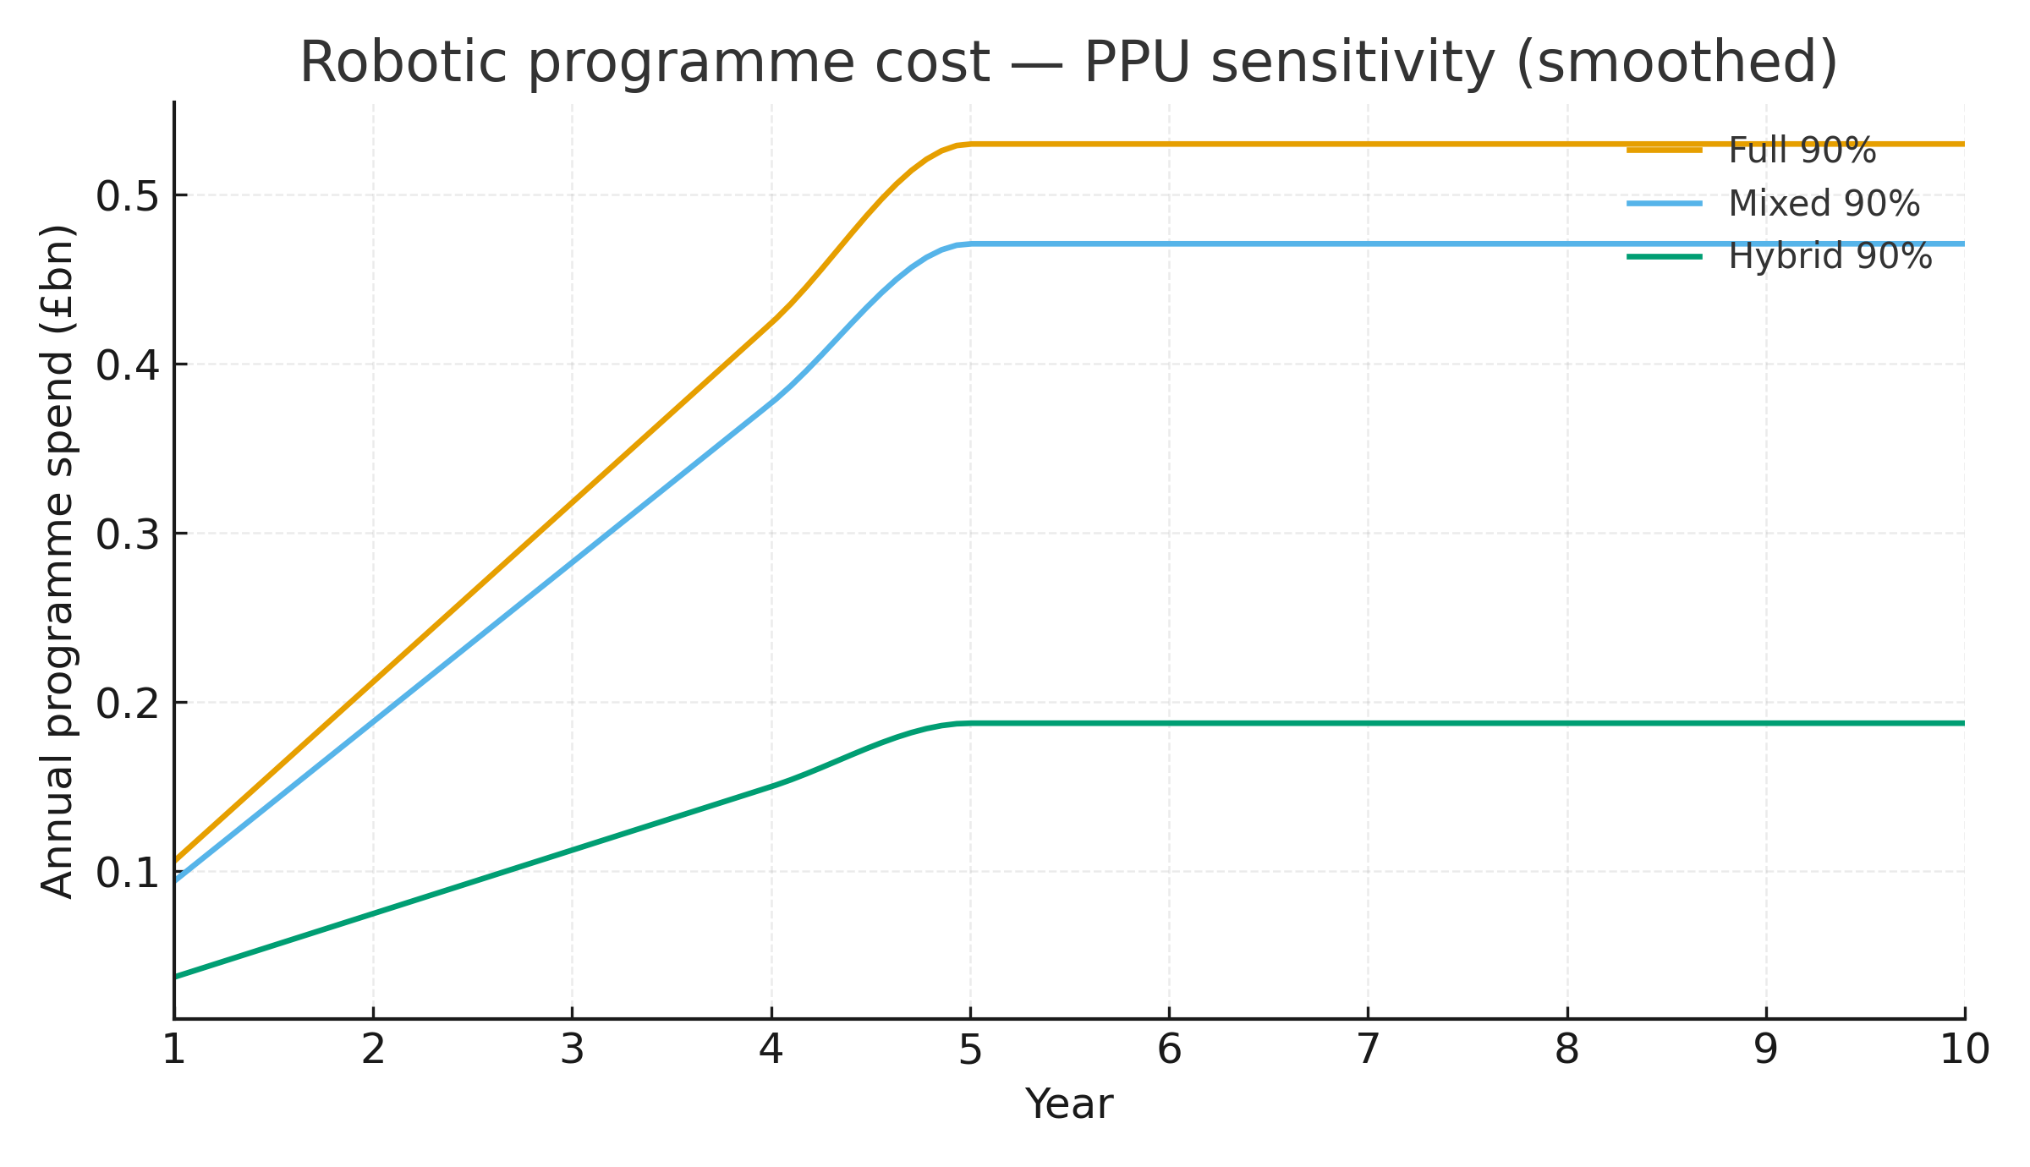
Figure S‑PPU‑2. Ten‑year totals: PPU sensitivity (90% scenarios).
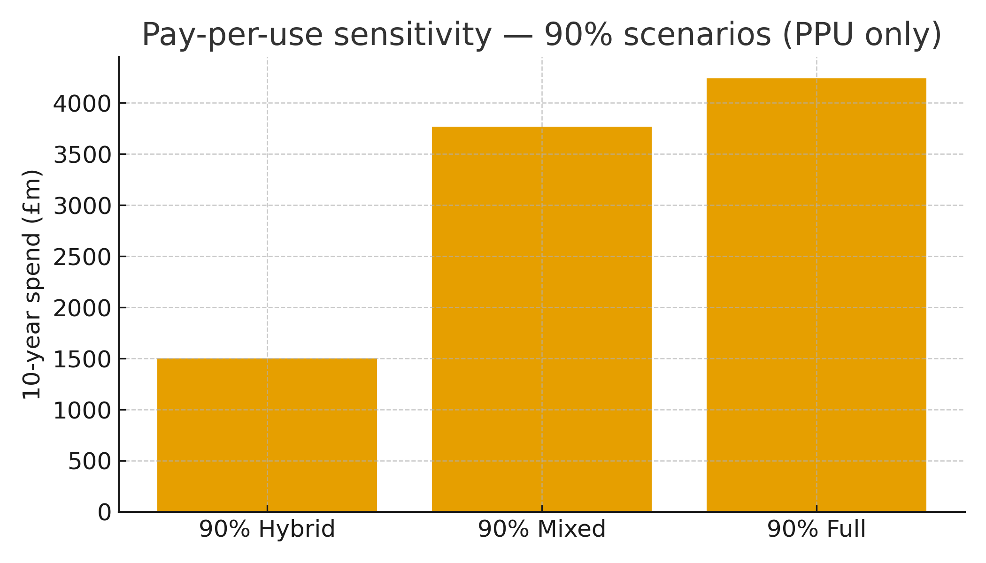

Supplement: Python code
# NHS soft-tissue robotics: national budget-impact model (capex route + PPU sensitivity)
# Requirements: Python 3.9+, pandas

import math
import pandas as pd

# -------- Parameters (paper defaults) --------
PRICES_CAPITAL = {'A': 1_800_000.0, 'B': 1_200_000.0, 'C': 250_000.0} # £ per system
PRICES_CONSUM = {'A': 2_000.0, 'B': 1_500.0, 'C': 250.0} # £ per case
CAPACITY_BASE = {'A': 250, 'B': 250, 'C': 350} # cases/system/year
REPL_RATE = 0.04 # 4% replacement in Y6–Y10
YEARS = list(range(1, 11))
INSTALLED_BASE = {'A': 112, 'B': 28, 'C': 0} # credited at start

# Year-10 annual robotic cases per platform (from Table 4 in manuscript)
Y10_CASES = {
"30% Hybrid": {'A': 9_989.9379, 'B': 8_327.0847, 'C': 40_011.0264},
"50% Mixed": {'A': 58_328.0490, 'B': 38_885.3660, 'C': 0.0},
"90% Full": {'A': 174_984.147, 'B': 0.0, 'C': 0.0},
"90% Mixed": {'A': 104_990.4882,'B': 69_993.6588, 'C': 0.0},
"90% Hybrid": {'A': 29_969.8137, 'B': 24_981.2541, 'C': 120_033.0792},
}

def ramp_series(cases_y10: dict) -> list[dict]:
"""Linear ramp to Year 5, then flat to Year 10."""
out = []
for y in YEARS:
scale = y/5.0 if y <= 5 else 1.0
out.append({p: cases_y10.get(p, 0.0) * scale for p in ['A','B','C']})
return out

def simulate_capex(scenario_name: str,
cases_y10: dict,
capacity: dict = CAPACITY_BASE,
prices_capital: dict = PRICES_CAPITAL,
prices_consum: dict = PRICES_CONSUM,
installed_base: dict = INSTALLED_BASE,
repl_rate: float = REPL_RATE) -> tuple[pd.DataFrame, pd.DataFrame]:
"""
Capex route:
- Fleet requirement = CEILING(cases / capacity) each year.
- Purchases each year = replacement (from Y6) + top-up to meet requirement after crediting installed base and prior fleet.
- Capital spend = purchases * capital price; Consumables = cases * per-case price.
Returns (annual_df, summary_df).
"""
ac_series = ramp_series(cases_y10)
fleet = installed_base.copy()
rows = []

for y, ac in zip(YEARS, ac_series):
req = {p: math.ceil(ac[p] / capacity[p]) if capacity[p] > 0 else 0 for p in ['A','B','C']}
replacement = {p: math.floor(repl_rate * fleet[p]) if y >= 6 else 0 for p in ['A','B','C']}
purchases = {}
for p in ['A','B','C']:
topup = max(0, req[p] - fleet[p]) # credit existing fleet
purchases[p] = replacement[p] + topup
fleet[p] = req[p] # end-of-year in-service
capex = sum(purchases[p] * prices_capital[p] for p in ['A','B','C'])
cons = sum(ac[p] * prices_consum[p] for p in ['A','B','C'])
rows.append({
'Scenario': scenario_name,
'Year': y,
'Cases_A': ac['A'], 'Cases_B': ac['B'], 'Cases_C': ac['C'],
'FleetReq_A': req['A'], 'FleetReq_B': req['B'], 'FleetReq_C': req['C'],
'Purch_A': purchases['A'], 'Purch_B': purchases['B'], 'Purch_C': purchases['C'],
'Capex_£m': capex/1e6, 'Consumables_£m': cons/1e6, 'Total_£m': (capex+cons)/1e6
})
df = pd.DataFrame(rows)
summary = (df.groupby('Scenario')
.agg(Year5_£m=('Total_£m', lambda s: round(float(s.iloc[4]), 2)),
Year10_£m=('Total_£m', lambda s: round(float(s.iloc[-1]), 2)),
Total10y_£m=('Total_£m', lambda s: round(float(s.sum()), 2)))
.reset_index())
return df, summary

# -------- Run base scenarios (replicates paper’s headline examples) --------
scens_to_run = ["30% Hybrid", "50% Mixed", "90% Full"]
annual_frames = []
summaries = []
for s in scens_to_run:
df, sm = simulate_capex(s, Y10_CASES[s])
annual_frames.append(df)
summaries.append(sm)

annual_all = pd.concat(annual_frames, ignore_index=True)
summary_all = pd.concat(summaries, ignore_index=True)

# summary_all now shows Year-5, Year-10 and 10-year totals (£m) for the three exemplars
# annual_all has per-year capex, consumables and totals

# -------- Pay-per-use sensitivity (90% mixes only) --------
def ppu_fee(prices_consum: dict, prices_capital: dict, capacity: dict, L_years: int = 7) -> dict:
"""Per-case PPU fee = consumables + (capital / (L * capacity))."""
return {p: prices_consum[p] + prices_capital[p] / (L_years * capacity[p]) for p in ['A','B','C']}

def simulate_ppu(scenario_name: str,
cases_y10: dict,
capacity: dict = CAPACITY_BASE,
prices_consum: dict = PRICES_CONSUM,
prices_capital: dict = PRICES_CAPITAL,
L_years: int = 7) -> tuple[pd.DataFrame, pd.DataFrame]:
fees = ppu_fee(prices_consum, prices_capital, capacity, L_years)
ac_series = ramp_series(cases_y10)
rows = []
for y, ac in zip(YEARS, ac_series):
spend = sum(ac[p] * fees[p] for p in ['A','B','C'])
rows.append({'Scenario': scenario_name, 'Year': y, 'PPU_Spend_£m': spend/1e6})
df = pd.DataFrame(rows)
summary = (df.groupby('Scenario')
.agg(Total10y_PPU_£m=('PPU_Spend_£m', 'sum'),
Year5_PPU_£m=('PPU_Spend_£m', lambda s: float(s.iloc[4])),
Year10_PPU_£m=('PPU_Spend_£m', lambda s: float(s.iloc[-1])))
.round(2)
.reset_index())
return df, summary

ppu_scens = ["90% Hybrid", "90% Mixed", "90% Full"]
ppu_annual_frames = []
ppu_summaries = []
for s in ppu_scens:
df, sm = simulate_ppu(s, Y10_CASES[s])
ppu_annual_frames.append(df)
ppu_summaries.append(sm)

ppu_annual_all = pd.concat(ppu_annual_frames, ignore_index=True)
ppu_summary_all = pd.concat(ppu_summaries, ignore_index=True)

# -------- Optional: print or save --------
if __name__ == "__main__":
pd.set_option('display.float_format', lambda v: f"{v:,.2f}")
print("\n=== Base scenarios (capex route) — summary (£m) ===")
print(summary_all.to_string(index=False))
print("\n=== Pay-per-use sensitivity (90% mixes) — summary (£m) ===")
print(ppu_summary_all.to_string(index=False))

