Supplement

Appendicitis Global Outcomes (AlliGatOr) Study Protocol: Identifying areas for whole systems strengthening in emergency care pathways

Appendices

Section 1 – List of authors
Section 2 – Supplementary tables and materials

Section 1: List of authors
Writing group
TTK Anyomih*‡, A Mulliez*, M Elhadi, A Ademuyiwa, A Adisa, A Dawson, A Matei, A Ramos-De la Medina, B Kadir, C Linder, D Ghosh, E Li, F Adjei, F Ntirenganya, H. Ekwunife, I Lawani, I Sanchez, J Glasbey, K Ooi, L. Bains, L Phelan, M Lapitan, M Picciochi, M Puerto, O Williams, P Agbonrofo, R Crawford, S Kamarajah, S Lawani, S Tabiri, V Ledda, V Michael, A Bhangu†, D Nepogodiev†‡.

*Joint first authors
†Joint last authors
‡Joint corresponding authors

Steering Committee
Name | Country
Amanda Dawson | Australia
Ismail Lawani | Benin
Jean-Leon Olory-Togbe | Benin
Janet Martin | Canada
Alazar Berhe | Ethiopia
Anita Eseenam Agbeko | Ghana
Fareeda Agyei | Ghana
Stephen Tabiri | Ghana
Maria Lorena Aguilera | Guatemala
Christina George | India
Dhruva Ghosh | India
Parvez Haque | India
Philip Alexander | India
Roy Nobhojit | India
Zipporah Gathuya | Kenya
Antonio Ramos de la Medina | Mexico
Irani Sanchez | Mexico
Adesoji Ademuyiwa | Nigeria
Adewale Adisa | Nigeria
Omolara Williams | Nigeria
Abdul Ghaffar | Pakistan
Lubna Samad | Pakistan
Marie Carmela Lapitan | Philippines
Allen JC Ingabire | Rwanda
Faustin Ntirenganya | Rwanda
Richard Crawford | South Africa
Aneel Bhangu | United Kingdom
David Naumann | United Kingdom
Dion Morton | United Kingdom
Dmitri Nepogodiev | United Kingdom
Elizabeth Li | United Kingdom
Ewen Harrison | United Kingdom
James Glasbey | United Kingdom
Maria Picciochi | United Kingdom
Matt Lee | United Kingdom
Sivesh Kamarajah | United Kingdom
Virginia Ledda | United Kingdom
Theophilus TK Anyomih | United Kingdom
Giana Davidson | United States of America
Rifat Atun | United States of America

Section 2: Supplementary materials, tables and figures
Table S1: Data collection periods & study timeline
Table 3: Data collection periods and study timeline
Data collection period | Follow-up
Data collection period 1  00:00 3 February 2025 - 23:59 16 Feb 2025 | 30-day follow-up ends 23:59 on 18 March 2025
Data collection period 2  00:00 17 February 2025 - 23:59 2 March 2025 | 30-day follow-up ends 23:59 1 April 2025
Data collection period 3  00:00 3 March 2025 - 23:59 16 March 2025 | 30-day follow-up ends 23:59 15 April 2025
Data collection period 4  00:00 17 March 2025 - 23:59 30 March 2025 | 30-day follow-up ends 23:59 29 April 2025
Data collection period 5  00:00 31 March 2025 - 23:59 13 April 2025 | 30-day follow-up ends 23:59 13 May 2025
Data collection period 6  00:00 14 April 2025 - 23:59 27 April 2025 | 30-day follow-up ends 23:59 27 May 2025
Data collection period 7  00:00 28 April 2025 - 23:59 11 May 2025 | 30-day follow-up ends 23:59 10 June 2025
Data collection period 8  00:00 12 May 2025 - 23:59 25 May 2025 | 30-day follow-up ends 23:59 24 June 2025
1 July 2025 | Final date of follow-up
15 July 2025 | Lock database

TEAM STRUCTURE AND AUTHORSHIP
Research outputs will be listed under a single corporate authorship (“NIHR Unit on Global Surgery”) and publications publicly available to all. All collaborators will be listed as PubMed-citable collaborators, so long as the minimum requirements for authorship are met. Collaborators will be listed according to authorship roles, summarised below:
- Local collaborators: mini-teams of up to three collaborators who actively participate in data collection over one or more 14-day data collection periods at a participating hospital. Health professionals approved by the hospital Consultant Lead can participate in mini-teams, including nurses, medical students, resident doctors / equivalent or consultants / equivalent.
- Hospital Consultant Leads: consultant surgeons with overall responsibility for study conduct within their hospital, including ensuring relevant national and/or local study approvals are in place (e.g. registration of the audit, submitting the protocol to Ethics Commission where applicable), recruiting and registering mini-teams, facilitating handovers between participating mini-teams (e.g. ensuring each mini-team collects data on all consecutive patients and that there is no duplication in data collection between mini-teams), and serving as a single point of contact for the study at their hospital.
If adults and paediatric surgical services are delivered by separate surgical teams, then sites can register separate consultant leads for both specialties. In that case, there will be mini-teams for each specialty per distinct data collection period.
They also ensure that study results are shared with relevant clinical teams locally and to the local research governance (ethics or audit) office.
- Hospital co-Leads: an additional local collaborator who supports the consultant lead. This role is optional and can be a consultant, resident doctor / equivalent, or medical student.
- National leads: global network responsible for coordination of the study within their country. They are responsible for ensuring any necessary national study approvals are in place. This involves identifying and recruiting hospitals to participate in the study and acting as a link between local teams (collaborators and consultant leads / hospital co-leads) and the operations committee. Where needed, they will facilitate translation of protocol and CRFs into local languages. If appropriate, countries may have an adult national lead and a paediatric national lead to support recruitment and in-country study management. Following completion of the study, they support dissemination of its findings.
- Operations committee: group with overall responsibility for protocol design, project coordination, data handling, and day-to-day administration of the study.
- Steering group: a diverse international, cross-disciplinary panel who ensure contextual and scientific relevance of the protocol design, data fields and interpretation.
- Writing group: group responsible for the overall scientific content, data analysis, and preparation of research manuscripts arising from the AlliGatOr study.
- Statistical analysis team: group with overall responsibility for the statistical analysis plan and quality assurance of data analysis.
The minimum requirements to be included as a local collaborating author on AlliGatOr study outputs will be:
- Successful clearance or approval by local standards to undertake AlliGatOr study at their site.
- Completion of the mandatory AlliGatOr site survey by the hospital Consultant Lead and/or hospital co-Lead.
- Participation in at least one data collection period, including at least one eligible patient, and uploading all data onto the REDCap database before the data lock deadline.

  - Data governance
All data will be captured and stored through Research Electronic Data Capture (REDCap) web application, a secure online data management system. REDCap allows collaborators to enter and store data in a secure system. The REDCap database used for the study is run by the NIHR Global Health Research Unit on Global Surgery (contact: Dr Dmitri Nepogodiev [d.nepogodiev@bham.ac.uk]), within the University of Birmingham Virtual Machine architecture, which is physically secured. The architecture is the responsibility of the Storage and Virtualisation Team at the University of Birmingham, Edgbaston, Birmingham, B15 2TT.
No sensitive or identifiable data will be uploaded or stored on the REDCap database. Each patient will be allocated a unique study number at entry on to REDCap, meaning that all data will be pseudo-anonymised. The central research team will not have any access to patient identifiable data. All communication will use this as the identifier.
Mini-team collaborators will be provided with personal REDCap login details. Two-factor verification (password plus a code sent via email or the Microsoft authenticator app) is mandatory for login. Mini-team collaborators will be able to securely submit data onto the REDCap system where they will only be able to access their own team’s data. Mini-teams should handle data in accordance with local data governance policies, and (if applicable) paper case report forms should be destroyed as confidential waste within the hospitals once uploaded to REDCap.
Once data collection is complete, the electronic research files containing anonymised data will be stored on secure non-networked desktop computers for up to 25 years, in line with current regulations. Access will be restricted to the researchers themselves. All data will be analysed and reported in summary format. No individual will be identifiable. The anonymised data generated by the study will be analysed by Omar Omar (Senior Statistician, University of Birmingham).
  - Ethics
The study will be carried out in accordance with national and international guidelines, as well as the basic principles of the protection of the rights and dignity of Human Beings, as set out in the Helsinki Declaration (64th Assembly Fortaleza, Brazil, in October 2013), and according to locally applicable legislation. Ethical approval for AlliGatOr has been granted by University of Birmingham Science, Technology, Engineering and Mathematics Committee (Reference number ERN_3201-Oct2024). The principal investigator for this study is Mr Theophilus Teddy Kojo Anyomih, University of Birmingham).
  - Local project registration
If possible, the study should be registered as an audit or service evaluation. Some hospitals may require an ethical clearance. It is the responsibility of the hospital Consultant Lead to ensure that all relevant study approvals are secured prior to starting data collection. Mini-teams should also ensure that the study is appropriately registered before commencing data collection.
When registering the study it should be emphasised that:
- If possible, a waiver for individual patient consent should be requested.
- There will be no changes to normal patient pathways or treatment. All data collected will measure current practice.
- Data will be collected and stored online through a secure server, Research Electronic Data Capture (REDCap) web application. REDCap allows collaborators to enter and store data in a secure system. Collaborators will be given secure REDCap project server login details, allowing secure data storage on the REDCap database.

PATIENT CASE REPORT FORMS (CRFs)
Table S2: Alligator patient case report forms (CRFs)
Data field | Options
Demographics CRF
Patient sex | Female / Male
Patient age | <52 weeks / 1-4 years / 5-9 years /10-17 years / 18-29 years / 30-39 years / 40-49 years / 50-59 years / 60-69 years / 70-79 years / 80-89 years / ≥90 years
Is the patient pregnant? | No - not pregnant / Yes - first trimester / Yes - second trimester / Yes - third trimester
American Society of Anesthesiologists (ASA) grade | Grade I / Grade II / Grade III / Grade IV / Grade V
Comorbidities | Ischemic heart disease / Congestive heart failure / Cerebrovascular disease / Chronic kidney disease / Diabetes Mellitus (NIDDM / IDDM)
Previous abdominal surgery | No / Yes - Open / Yes - Minimally Invasive Surgery
Was there a previous episode of right iliac fossa pain leading to hospital attendance (ED attendance or in-patient admission) within the 30 days before this admission?  *If they were transferred from one hospital to this hospital, this would count as one episode | No / Yes - appendicitis was not suspected / Yes - appendicitis was suspected but managed conservatively due to inflammatory mass / Yes - appendicitis was suspected but managed conservatively due to patient choice / Yes - appendicitis was suspected but managed conservatively for other reasons
Presentation on this episode of care CRF
Symptoms at presentation | Generalised abdominal pain / Right iliac fossa pain / Bowel symptoms (diarrhoea / constipation) / Nausea / Vomiting / Loss of appetite / Migration of abdominal pain to right iliac fossa
Signs at presentation | Fever (>38) / RIF tenderness / Localised right iliac fossa peritonism / Generalised peritonism / Rovsing’s sign positive / Psoas sign positive / Obturator sign positive
Immediately prior to attending this hospital, did the patient seek care from anywhere before attending this hospital? | No / Yes - Traditional healer / Yes - Community health worker / Yes - Family/primary care doctor / Yes - Other hospital that referred this patient to this hospital / Yes - other (e.g. pharmacy)
If ‘Yes’ to any of the above, describe their pathway from symptom onset to this hospital, including the reason for any inter-hospital transfer | Free text (optional)
Time from symptom onset to first assessment by the surgical team in this hospital  *Eg If it is only 12hrs, please indicate 0 days, 12hrs… | Days…….  Hours…….
Time from first assessment by the surgical team in this hospital to patient arriving in theatre  *Eg If it is only 12hrs, please indicate 0 days, 12hrs… | Days…….  Hours…….
Was any appendicitis risk scoring done? | No / Yes - Paediatric appendicitis score / Yes - Adult Appendicitis Score / Yes - Appendicitis Inflammatory Response Score / Yes - Alvarado score / Yes - Other
Was an ultrasound performed preoperatively? | No / Yes - confirmed appendicitis / Yes - equivocal result / Yes - no evidence of appendicitis
Was a CT scan performed preoperatively? | No / Yes - confirmed appendicitis / Yes - equivocal result / Yes - no evidence of appendicitis
Was an MRI scan performed preoperatively? | No / Yes - confirmed appendicitis / Yes - equivocal result / Yes - no evidence of appendicitis
Which of the following blood tests were performed preoperatively | CRP / White Cell Count / None of the above
If WCC performed, value | ……. (x10⁹/L)
If CRP performed, value  *Normal range (less than 5 mg/L) | ……. (mg/L)
Most senior surgeon who reviewed patient prior to the decision to operate | Consultant or equivalent level of experience / Doctor with >3 years’ experience but not consultant / Doctor with <3 years’ experience / non-physician (E.g. physician assistant, nurse etc)
Intraoperative CRF
Grade of most senior surgeon scrubbed | Consultant or equivalent level of experience / Doctor with >3 years’ experience but not consultant / Doctor with <3 years’ experience / non-physician (E.g. physician assistant, nurse etc)
Time of knife to skin | 0800 - 17:59 / 1800 - 2359 /0000 - 0759
Approach | Open - Lanz / Open - Other non-midline / Open – Midline / Laparoscopic / Laparoscopic converted to open / Robotic / Robotic converted to open / Natural orifice
If open approach, reason(s) for not taking laparoscopic approach?  *E.g. of consumables specimen bag, endoloop | Clinical contraindication / Cost of laparoscopy / Lack of laparoscopic equipment / Lack of laparoscopic consumables / Lack of laparoscopy trained surgeon / Surgeon preference / Patient preference / Unstable electricity supply / Lack of carbon dioxide / Patients could not afford to pay for laparoscopy
Additional procedure(s) performed | None / Right hemicolectomy / Resection of Meckel’s diverticulum / Small bowel resection / Gynaecological procedure / Washout +/-drain / Other
Macroscopic appearances of appendix intra-op | Normal appendix / Simple appendicitis / Complex appendicitis (gangrenous or perforated)
Was there a power outage in the operating room (OR) during the operation? | Yes, 1-14 minutes / Yes, 15 -29 minutes / Yes, 30-59 minutes / >1hr / No / Not sure
If yes, what did you have to do differently as a result of the power outage? | No changes to procedure / Conversion from laparoscopic to open / Use of torch light (phone, headlight) / Change in mode of anaesthetic / Other (please specify)
Did the power outage result in a complication?  *Grade the highest complication | No impact / Minor complication (CD grade I) eg minor delay in procedure, minor burning to skin / Moderate complication (CD grade II) eg mild hypothermia, delay in antibiotic administration / Severe complications (CD grade III) eg bleeding requiring immediate intervention or reoperation / Life-threatening complications (CD grade IV) eg affecting patient ventilation or life sustaining equipment / Death of patient (CD grade V) eg delay or unavailability of vital equipment resulting in patient’s death
Follow-up CRF
Were antibiotics administered? | Yes – before surgery / Yes – at induction/theatre (+/- 6h) / Yes – postop <24hrs / Yes – postop 24hrs – 5days / Yes – postop > 5days / Unsure / None
30-day surgical site infection | No / Yes
30-day reoperation | No / Yes
30-day overall Clavien-Dindo complication grade | None / Grade I / Grade II / Grade III / Grade IV / Grade V (Death)
Post-operative length of hospital stay (in days) considering day of surgery as day 0  *If discharged on day of surgery, enter 0 | …….. Days
30-day readmission | No / Yes
If yes, length of hospital re-admission stay (in days)  *If readmitted and discharged, enter 0 | …………..
Histology | Normal appendix / Simple appendicitis / Complex appendicitis (gangrenous or perforated) / Adenocarcinoma / Carcinoid / Mucocele / Crohn’s disease / Other

Table S3: Study definitions

Surgical site infections
Surgical site infection is defined at 30 days post-surgery using the Centers for Disease Control (CDC) definition of deep incisional or superficial incisional SSI as follows
- The infection must occur within 30 days of the index operation
- The infection must involve the skin, subcutaneous, muscular, or fascial layers of the incision
- The patient must have at least one of the following: purulent drainage from the wound; organisms detected by wound swab; diagnosed clinically or at imaging; wound opened spontaneously or by a clinician
- The patient has at least one of the following: pain, tenderness, localized swelling, redness, heat at the wound site, systemic fever (>38°C).³

Clavien-Dindo classification

In the Clavien-Dindo classification of post-operative complications, a complication is any deviation from the normal post-operative course that has an adverse effect on the patient and is not either a treatment failure (i.e. original surgery fails to achieve its intended benefits; e.g. tumour recurrence following cancer surgery) or sequelae (i.e. recognised consequences of a given procedure; e.g. immune deficiency following splenectomy).⁴

In the Clavien-Dindo classification, the factor determining the severity of a complication is the treatment required (Table 4). A given complication may be graded differently depending on how it has been managed. For example, an anastomotic leak may be managed just with antibiotics if it is contained (grade II) or it may require re-operation under anaesthetic (grade IIIb).

Some other considerations:
- For AlliGatOr, if a patient has experienced multiple complications, please record the single highest Clavien-Dindo grade scored.
- Intra-operative complications are not considered unless they have an adverse effect on the patient post-operatively. The exception to this is intra-operative death; this is classified as grade V.
- All post-operative adverse events within the follow-up period (30 days) are included, even when there is no direct relationship to the surgery, including complications occurring following discharge.
- Diagnostic procedures are not included. For example, a diagnostic oesophagoduodenoscopy (OGD) to look for a source of bleeding without any intervention would not be considered a complication, but a therapeutic OGD with clipping of a bleeding vessel would be considered a grade III complication. Since negative exploratory laparotomies are considered diagnostic procedures, they should not be recorded as complications.
Clavien Dindo Classification
Grade I
Any deviation from the normal postoperative course without the need for pharmacological (other than “allowed therapeutic regimens”), surgical, endoscopic or radiological intervention.
Allowed therapeutic regimens are: selected drugs (antiemetics, antipyretics, analgesics, diuretics and electrolyte replacement), physiotherapy and wound infections opened at the bedside but not treated with antibiotics.

Examples: Ileus (deviation from the norm); hypokalaemia treated with K; nausea treated with cyclizine; acute kidney injury treated with intravenous fluids.
Grade II
Requiring pharmacological treatment with drugs beyond those allowed for grade I complications; including blood transfusions; total parenteral nutrition.

Examples: Surgical site infection treated with antibiotics; myocardial infarction treated medically; deep venous thrombosis treated with enoxaparin; pneumonia or urinary tract infection treated with antibiotics; blood transfusion for anaemia.
Grade III
Requiring surgical, endoscopic or radiological intervention.

Examples: Therapeutic endoscopic therapy (do not include diagnostic procedures); interventional radiology procedures; return to theatre for any reason
Grade IV
Life-threatening complications requiring critical care management; brain haemorrhage; or ischemic stroke (excluding TIA). Examples: Pneumonia with ventilator support, renal failure with filtration; SAH; stroke
Grade V
Death of a patient

Table S4: Data guide

Demographics Form

Data field | Notes
Age | Select the patient’s age in years on the day of surgery from the dropdown menu. For infants under 1 year of age, also select their age in months.
Sex | Select sex, as assigned at birth.
American Society of Anaesthesiologists (ASA) grade | Select ASA grade, as measured on the day of surgery.  Grade I: Normal healthy patient without any systemic disease or physiological disturbances.  Grade II: Patient with mild systemic disease that is controlled and does not limit their daily activities (e.g. well-controlled diabetes or hypertension, mild asthma, or a patient who is pregnant).  Grade III: Patient with severe systemic disease that limits their activities but is not incapacitating (e.g. patient with poorly controlled hypertension, stable angina, or COPD).  Grade IV: Patient with severe systemic disease that is a constant threat to life (e.g. a patient with unstable angina, heart failure, or advanced renal disease requiring dialysis).  Grade V: Moribund patient not expected to survive without the surgical intervention (e.g. a patient with a ruptured abdominal aneurysm or massive trauma).
Previous abdominal surgery | Select whether the patient has had any previous abdominal surgery. This could include (not exhaustive list): cholecystectomy, hernia repair, colorectal surgery, c-section, etc  Select whether this was open (any open incision, including laparoscopic/robotic converted to open) or minimally invasive (laparoscopic or robotic). If the patient has had multiple previous surgeries, you can tick both open and minimally invasive boxes.
Comorbidities | Tick all the appropriate options for this patient.  - Ischaemic heart disease includes myocardial infarction, angina, history of Coronary artery bypass graft surgery, or history of percutaneous transluminal coronary angioplasty.  - Cerebrovascular disease includes both stroke and transient ischaemic attack (TIA).  - Chronic kidney disease (CKD) should be an established CKD diagnosis – please take care to not confuse with an acute kidney injury.  - Diabetes mellitus includes both type 1 and type 2 diabetes mellitus.  If there is no hospital record to confirm whether a patient does or does not have a comorbidity, please record the patient as not having that comorbidity.  If appropriate, you can tick multiple comorbidity boxes. If the patient has none of these comorbidities, tick "None of the above".
Was there a previous episode of right iliac fossa (RIF) pain leading to emergency department attendance or in-patient admission within the 30 days before this admission? | A “previous episode” means that the patient attended an emergency department or was admitted to hospital with RIF pain, and then discharged home with no plan for further inpatient treatment. If a patient was transferred from one hospital directly to this hospital this would considered the same as the current episode, so tick ‘no’.  If yes, please select the single best matching statement relating to whether appendicitis was suspected or not on the previous admission and, if so, why appendicectomy was not performed. If there were multiple previous episodes in the previous 30 days, please consider the most recent episode.

Presentation on this Episode of Care Form

Data field | Notes
Symptoms at presentation | Select all the symptoms that the patient had when they were first assessed by the surgical team on this presentation. If the patient has none of these symptoms, tick “None of the above”.
Signs at presentation | Select all the signs that the patient had when they were first assessed by the surgical team on this presentation. If the patient has none of these symptoms, tick “None of the above”.  Rosving’s sign: pain in right lower quadrant of the abdomen when applying pressure to the left lower quadrant.  Psoas sign: right lower quadrant pain when extending right hip.  Obturator sign: right lower quadrant pain during internal rotation of the flexed hip.
Immediately prior to attending this hospital, did patient seek care from anywhere else? | Select the places where the patient sought care during this episode, before attending your hospital. If you select any of the “yes” options, please use the text box to describe the patient’s pathway from first onset of symptoms to presenting at your hospital on this episode.
Time from symptom onset to first assessment by the surgical team | Please select the time from when symptom onset on this episode to the patient first being assessed by the surgical team in your hospital.
Time from first assessment by the surgical team in this hospital to patient arriving in theatre | Please select the time from when symptom onset on this episode to the patient first being assessed by the surgical team in your hospital.
Was any appendicitis risk scoring done? | Risk scoring is not required as part of the AlliGatOr protocol. Only record if risk scoring was performed routinely, unrelated to AlliGatOr.
Which of the following blood tests were performed preoperatively? | Please select whether C-reactive protein (CRP) and/or white cell count (WCC) blood tests were performed before the operation. If so, enter the numerical values in the fields that appear:  - For WCC, please enter the value as x10⁹/L (typical normal is 4-11).  - For CRP, please enter the value as mg/L (typical normal is <5).
Was an ultrasound performed preoperatively? | Only consider scans abdominal/pelvic scans. If a scan was performed, please record the result:  - Appendicitis confirmed: scan reported as demonstrating inflamed appendix.  - Appendicitis ruled out: scan reported as demonstrating normal appendix.  - Equivocal: scan reported as being unable to either confirm or disprove a diagnosis of appendicitis with any certainty.
Was a CT scan performed preoperatively?
Was a MRI scan performed preoperatively?
Most senior surgeon who reviewed patient prior to the decision to operate | Please select the grade of the most senior surgeon who reviewed the patient in-person. If a senior surgeon was consulted by another team member by telephone, this should not be considered for the purpose of this question. A consultant (attending) surgeon is defined as a surgeon who has completed a formal surgical training programme and been accredited as a specialist surgeon.

Intraoperative Form

Data field | Notes
Grade of the most senior scrubbed surgeon | Please select the grade of the most senior scrubbed surgeon. If a surgeon is not scrubbed, they should not be considered for the purpose of this question. A consultant (attending) surgeon is defined as a surgeon who has completed a formal surgical training programme and been accredited as a specialist surgeon.
Time of knife to skin | Please select the time of knife to skin.
Approach | Please select the option from the list that best describes the approach for this operation  If you select any of the “open” options, please select the reasons for not taking a laparoscopic approach. If there are multiple reasons, select all the options that apply. If you select “Other”, a field will appear where you should provide further details.
Additional procedure(s) performed | Please select whether any extra procedures were performed in addition to appendicectomy. Tick multiple boxes, as appropriate.  If you select “other”, please use the text box to give further details.
Macroscopic appearances of appendix intra-op | Please select the appearance of the appendix during the operation as recorded on the operation note:  - Normal appendix: may be described ‘lily white’.  - Simple appendicitis: injected/ inflamed appendix that does not have ‘complex’ features.  - Complex appendicitis: gangrenous, perforated, purulent, or necrotic appendix.
Was there a power outage in theatre? | Please select whether there was any power (electricity) outage in the theatre from the time the patient entered the anaesthetic room/ operating room to the time they left. If so, select the option that reflect the duration of the outage (if there were multiple power outages, calculate their total duration of outages).  If you select that there was a power outage, two additional fields will appear:  - “Did the power outage result in patient harm?” – please rate this as No impact, Minor complication (e.g. extended operating time, increased bleeding which was controlled), Moderate complication (e.g. increased bleeding which resulted in a postoperative haematoma), Life-threatening complication (e.g. anaesthetic complications resulting in cardiac or respiratory compromise).  - “Please describe what did you have to do differently as a result of the power outage and what the impact was on the patient’s outcome” – please write a brief summary in the open text box.

30-day Follow-up (Postoperative) Form

Patients should be followed-up at postoperative day 30 (taking the day of surgery as postoperative day 0) or later. The 30-day outcomes should only include complications or mortality up to and including postoperative day. No change to routine patient care and pathways should be made, so 30-day AlliGatOr follow-up should be based on existing hospital records.

Follow-up should be based on all information routinely available at 30-days, for example:
- Inpatient hospital notes (paper or electronic) relating to the index admission and any readmissions that the patient has had.
- Records from outpatient (clinic) reviews or telephone calls (if such reviews/ calls are routine practice at the hospital).
- Review of electronic hospital records to identify readmissions.
- Review of electronic hospital records to identify patients recorded as having died.
- Review of drug charts, imaging reports, and pathology reports.

Data field | Notes
When were antibiotics administered? | Please select whether antibiotics were administered during this admission, and if so, when. Tick multiple boxes, as appropriate.  If antibiotics were administered, an additional field will appear where you should select all the classes of antibiotics that were administered to the patient (one or more doses) during this admission. Tick multiple boxes, as appropriate.
30-day surgical site infection | Surgical site infection is defined at 30 days post-surgery using the Centers for Disease Control (CDC) definition of deep incisional or superficial incisional SSI as follows:  - The infection must occur within 30 days of the index operation.  - The infection must involve the skin, subcutaneous, muscular, or fascial layers of the incision.  - The patient must have at least one of the following: purulent drainage from the wound; organisms detected by wound swab; diagnosed clinically or at imaging; wound opened spontaneously or by a clinician.  - The patient has at least one of the following: pain, tenderness, localized swelling, redness, heat at the wound site, systemic fever (>38°C).
30-day unplanned reoperation | Please select whether the patient had an unplanned reoperation within 30 days of surgery (day of surgery is day zero) related to their initial appendicectomy. Do not include planned reoperations (e.g. planned return to theatre to close an open abdomen).
Post-operative length of hospital stay | Please enter the post-operative length of hospital stay in days, considering day of surgery as day 0. Do not include the preoperative length of stay in this figure.  If the patient was discharged on day of surgery, enter 0. If patient is still on admission on post-operative day 30, enter 30.
30-day overall Clavien-Dindo complication grade | Please see detailed guidance below.
Histopathology | Please select the best match for findings on histopathological examination of the appendix.  - Normal appendix: no evidence of acute inflammation of other pathology.  - Simple appendicitis: injected/ inflamed appendix that does not have ‘complex’ features.  - Complex appendicitis: gangrenous, perforated, purulent, or necrotic appendix.  - Other options: Adenocarcinoma, Carcinoid, Mucinous cystadenoma, Mucocele, Crohn’s disease, Amyloidosis, Endometriosis, Parasite.  Note: If histopathology is not available on postoperative day 30, please check back later and enter the histopathology result even if it returns after postoperative day 30. If histopathology is not available, select “Histopathology not performed”.
Was a faecalith identified? | Please select whether a faecalith (appendicolith) was identified on diagnostic imaging, intraoperatively during surgery, or on histopathological examination? Multiple boxes can be ticked, if appropriate.
30-day readmission | Please select whether the patient was readmitted within 30 days of surgery (day of surgery is day zero) for any reason to this or any other hospital.

HOSPITAL LEVEL SURVEY
Table S5: Alligator mandatory site survey

Data criteria | Options
Hospital type | •Primary level - few specialties, mainly internal medicine, obstetrics & gynaecology, paediatrics and general surgery, or just general practice. Limited laboratory services available and no specialised pathological analysis (i.e., 'district', 'rural', or 'community' hospital)  •Secondary level - more differentiated by function with as many as 5 to 10 clinical specialties, usually from 200 to 800 beds (i.e., 'regional', 'provincial' or 'general' hospital)  •Tertiary level - highly specialised staff and technical equipment, clinical services highly differentiated by function, may have teaching activities, usually from 300 to 1,500 beds (i.e., 'national', 'central', 'academic', 'teaching' or 'university' hospital)
Hospital ownership | Government, publicly owned / Not-for-profit organisation e.g., charity, NGO / For-profit organisation / Public-private partnership
How is the majority of the cost of care for patients in your hospital paid for?  *One option only | Public insurance (funded by government) / Private insurance (insurance paid for by the patient) / Corporate insurance (funded by patient's employer) / External funds or grants awarded by charities or NGOs / Out of pocket payments (patient paid the hospital directly) / Not known / Other (free text)
What cohort of patients are managed in your hospital? | Paediatrics only / Adults only / Paediatrics and adults
Total number of hospital beds | ……….. beds
Is ultrasound service available for patients with right Iliac Fossa pain? (TICK ALL THAT APPLY)  *E.g. US may be available in a facility for obstetrics but not for right iliac fossa pain assessment, in this instance tick ‘Not available | Yes, available at all times / Yes, available only during working hours / Yes, available out of working hours but only for urgent surgical requests / Yes, available at a cost to ALL patients / Yes, available at a cost to some patients / Yes available at NO COST to patients / Not available
Is CT scan available in your facility? | Yes, available at all times / Yes, available only during working hours / Yes, available out of working hours but only for urgent surgical requests / Yes, available at a cost to ALL patients / Yes, available at a cost to some patients / Yes available at NO COST to patients / Not available
Is MRI available in your facility? | Yes, available at all times / Yes, available only during working hours / Yes, available out of working hours but only for urgent surgical requests / Yes, available at a cost to ALL patients / Yes, available at a cost to some patients / Yes available at NO COST to patients / Not available
Is there a policy in your hospital/department regarding the use of appendicitis risk stratification scores? | Yes, use of score recommended / Yes, use of score discouraged / No policy in place
Is laparoscopy available at your facility? | Yes, available all the time / Yes, available only during working hours / Yes, available occasionally / Not available
If ‘Not available’ or ‘Yes - available occasionally’, what are the reasons for this?  [Branching logic] (TICK ALL THAT APPLY) | Lack of equipment / Lack of trained surgical practitioner / Lack of trained anaesthesia provider/ Lack of trained peri-operative staff / Lack of carbon dioxide / Lack of other consumables / Other
Do you have access to histopathology services? | Yes, available on site / Yes, available offsite / Not available
Do patients have to pay out-of-pocket for this histopathology services? | Yes / No / Sometimes
What is the cost of an open appendectomy? | Free text, in local currency
What is the cost of a laparoscopic appendectomy? | Free text, in local currency
What is the cost of one night stay in hospital? | Free text, in local currency
If patient pays out of pocket, can that influence the choice of operative approach or instruments and devices used? | Yes / No
What kind of drapes are used in the operating room in your facility? | Reusable / Disposable / Both
What kind of gowns are used in the operating room in your facility? | Reusable / Disposable / Both
Was the waste produced during the operation: | Collected all together with no differentiation / Differentiated into clean and contaminated (Contaminated- soiled with blood, mucus, other bodily fluid) and collected separately / Differentiated into clean, contaminated and sharps and collected separately
On average, how often do you have power outages in the operating theatre? | Once a year/ Once a month / Once a week / Several times a week / Once a day / multiple times a day
On average, how often do you have power outages elsewhere in the hospital? | Once a year/ Once a month / Once a week / Several times a week / Once a day / multiple times a day
Do you have a functioning backup power generator? | Yes, comes on within a minute of power outage / Yes, takes longer than a minute / No
Waste collection in OPERATING THEATRES
Regarding Waste collection in operating theatres Do you separate your waste into clean and contaminated waste? | Yes, use different collecting bins / Yes, use color-coded bins / Yes, use labelled bins / No, we do not separate / Unsure
Who is in charge of separating and sorting the waste in the operating theatre? [Branching logic if any ‘Yes’ options above] | Clinical team / waste collectors/ other (please specify)
Waste storage and management OUTSIDE OPERATING THEATRES
Who is in charge of removing waste from the operating theatres? | Clinical team/ waste collectors/ Other (please specify)
Is there a dedicated waste storage facility in your hospital? | Yes, different types of waste (clean/contaminated) stored separately / Yes, different types of waste (clean/contaminated) stored in the same place / No / Unsure
Waste processing
What happens to waste collected in your hospital- how is this processed (eg Incineration, landfill) | Yes, Open-air incineration / Yes, Formal incineration process with a dedicated facility / Yes, landfill / Unsure / Other (please specify)
Who is in charge of taking waste collected in hospital for processing? | Clinical teams/ waste collectors from the hospital/ External company/ Other (please specify)
How often is waste collected in hospital removed and taken for processing? | More than once a day / Once a day /  4-6 times a week / 1-3 times a week / Less than weekly
Waste management pathways
Does your hospital have records of the waste generated per day? | Yes/ No /Unsure
Are there any official documents regulating waste collection in your hospital? | Yes – National policy or guidelines / Yes – Regional policy or guidelines / Yes – Hospital policy or guidelines / No/ Unsure
Does your hospital have medical waste management committee? | Yes / No
Does the staff in charge of waste management in your hospital receive formal training on waste management? | Yes – one off training / Yes – at least once a year / Yes – at least once a month / No / Unsure

Table S6: Substudies patient case report forms (CRFs)

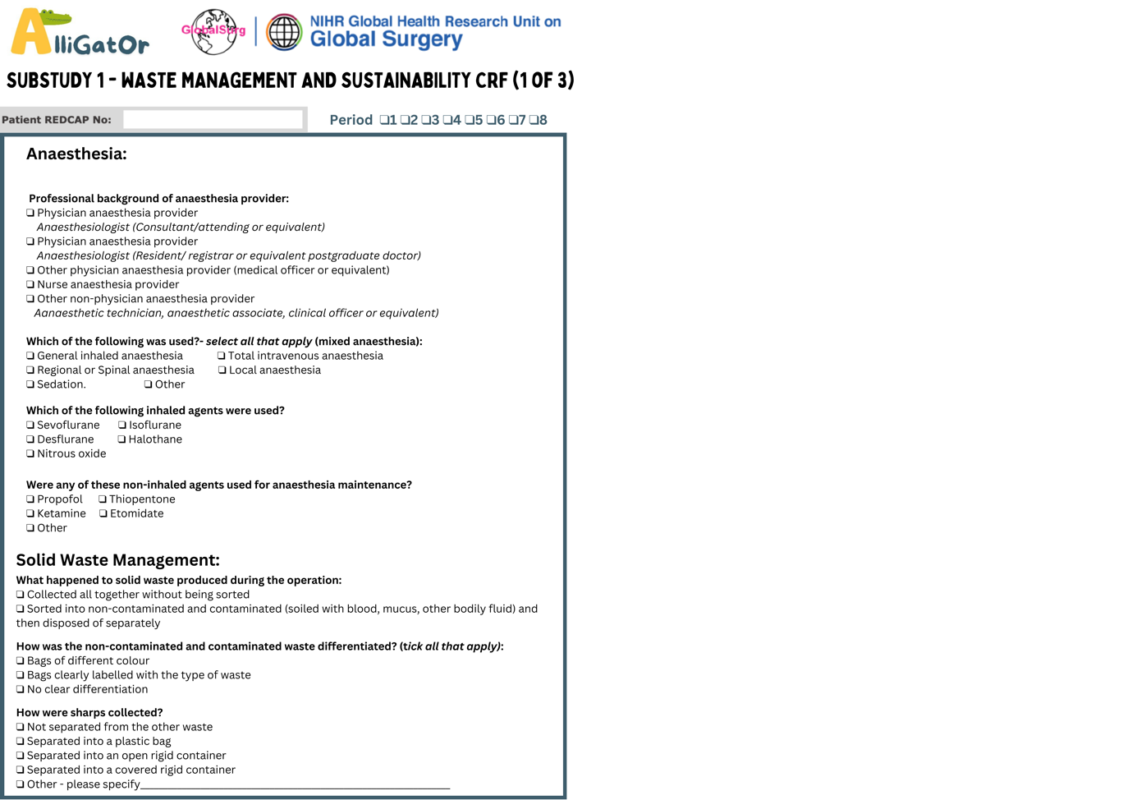
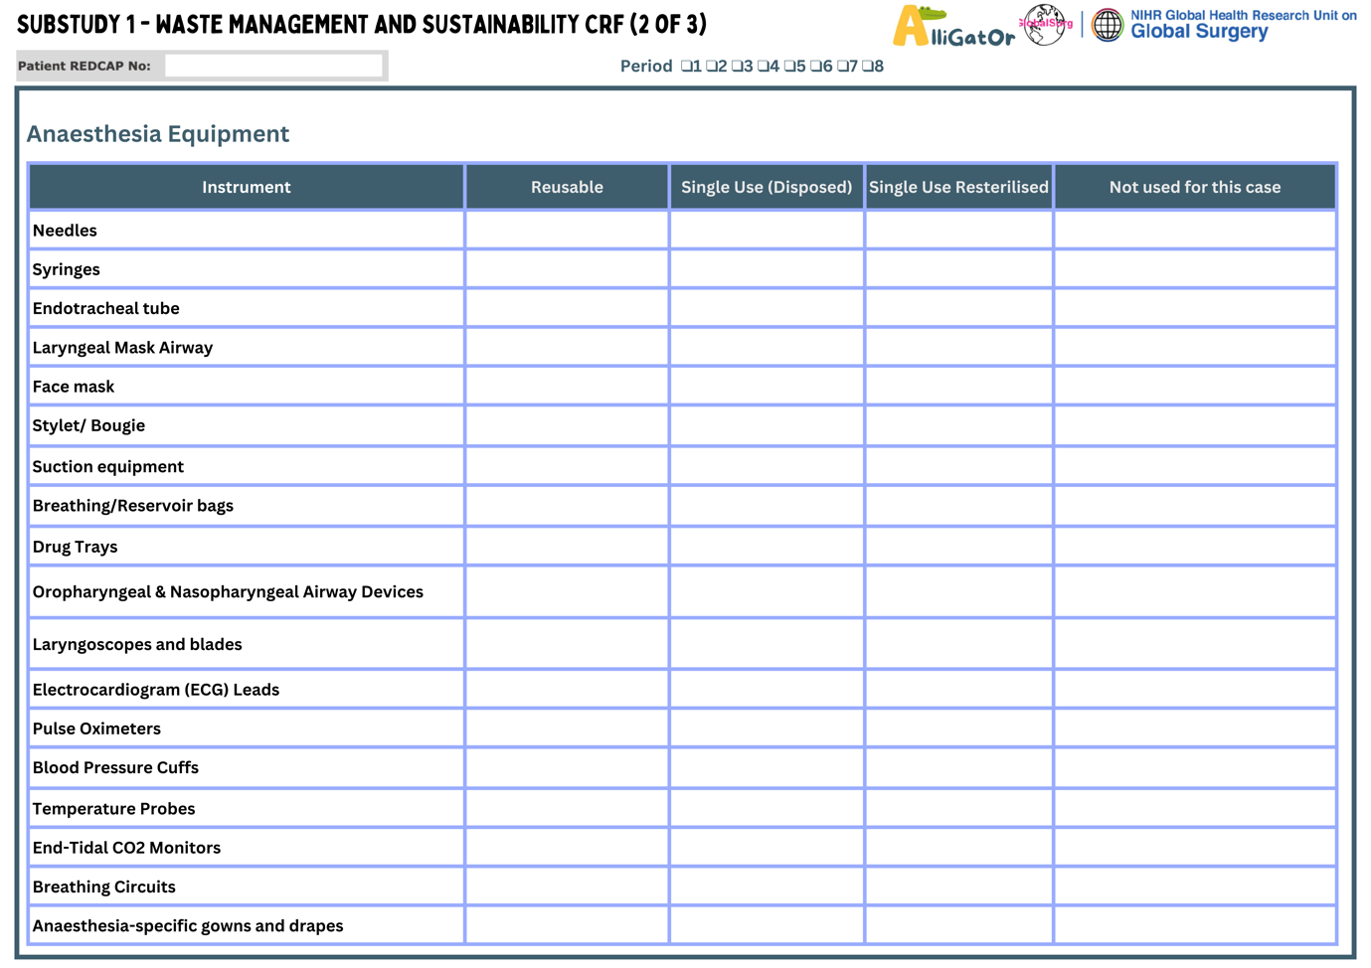
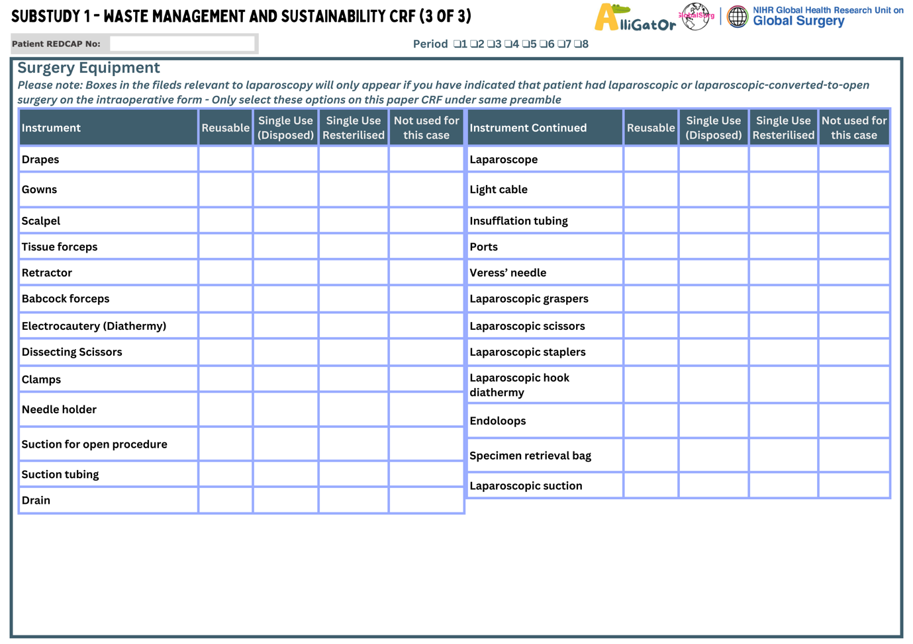

Table S7: SPIROS Checklist
Section / Item | Description | Page where addressed (Supplement)*
Part A: General information
Title | Descriptive title Identifying study design in the title | 1
Protocol version | Version or amendment number with date and summary of the changes | 1
Protocol summary | An informative and balanced summary of the study protocol | 2
Sponsor and funder details | Name of Sponsor and funder and types of financial, material, and other support | 1
Conflict of interest statements | Statement about any financial and other competing interests for principal or co-investigators for the overall study. | 1
Investigators name | Names of the principal and co-investigators | 1
Affiliation of investigators | Affiliated institutions of the investigators | 1
Principal researcher/s contact detail | Name, e-mail address, affiliation of principal researcher | 1
Part B: Introduction
Background of the study | Description of research question and scientific background of the study | 3
Review of prior research | Summary of relevant existing research (published or unpublished) | 3
Rationale of study | Justification for conducting the study | 3
Aim | Broader aims and overall objective | 3
Objective/s of the study | Primary and secondary objective/s including any prespecified hypothesis (if applicable). | 3
 | Specify whether the intention is to (a) estimate causal effects,  (b) predict outcomes, or (c) simple description. | 3
Part C: Methods
Study design | Description of study design (case control, cross-sectional or cohort) and type of study (retrospective cohort study, Prospective cohort study etc) | 4
Study setting | Description of the study setting (e.g., community-based, hospital based) and detail of precise locations of the study sites. | 4
Study schedule | Description of the expected schedule of the study including relevant dates, expected periods of recruitment/survey, exposure, follow-up, and data collection. | 4
 | Figure (Study schematic/flow-chart) or table describing expected time frame for each step including trainings, data collection, follow-up, analysis and reporting etc. | 4*
Sample size | Estimation of minimum sample size required for the study with justifications including clinical and statistical assumptions supporting any sample size calculations. | 7
Sampling procedure | Detailed description of the sampling frame and sampling strategy (simple random, stratified random, cluster, systematic etc.) | NA
Participant selection
Participant selection for cohort study | Description of inclusion and exclusion criteria, and the source and methods of participant selection (exposed and unexposed). For matched cohort studies, give matching criteria and number of exposed and unexposed. | 4, 13
Participant selection for case-control study | Description of inclusion and exclusion criteria, and the source and methods of case ascertainment and control selection.  Give the rationale for the choice of cases and controls. Give diagnostic criteria for identifying cases (if applicable). For matched case-control studies, give matching criteria and the number of controls per case. | NA
Participant selection for cross-sectional study | Description of the inclusion and exclusion criteria, and the source and methods of participant selection. | NA
Variables | Detailed description of all important baseline and outcome variables to be analysed, exposures, predictors, potential confounders, and effect modifiers. Give diagnostic criteria, if applicable. | 4
Data sources/measurement | For each variable of interest, give sources of data and details of assessment /measurement methods. Describe comparability of assessment methods if there is more than  one group. | 5
Data collection and management | Plans for assessment and collection of outcomes, baseline, follow up and other study related data. | 5
 | Description of data collection methods e.g., online survey, Household survey, paper based or electronic data capture  etc. | 5
 | Any related processes to promote data quality during data collection (e.g., duplicate measurements, training of assessors, validation method) | 6*
 | Description of study instruments (e.g., questionnaires, data collection forms) along with their reliability and validity, if known. Reference to where data collection forms can be found, if not in the protocol. | 8
 | Plans for data entry, coding, security, and storage, including any related processes to promote data quality (e.g., electronic data capture, double data entry; range checks for data values, random cross-checking of electronic data with the source documents).
 | Reference to where details of data management procedures can be found, if not in the protocol. | 8
Blinding procedure (if blinded study) | Description of blinding procedure (if applicable) reporting Who will be blinded (e.g., investigator blinded for disease status when measuring exposure in case-control study) and methods to ensure blinding and unmasking of blinding if  required. | NA
Potential bias | Description of any potential biases and plan to minimize those potential sources of biases. | NA
Statistical analysis plan | Detailed description of methods for analysing and presenting primary/secondary outcomes and any additional analysis (e.g. analyses of subgroups and interactions, and sensitivity analyses). Give reference to the where other details of the statistical analysis plan can be found, if not in the protocol. | 8
Handling of missing data | Detailed description of methods to handle missing data (e.g. multiple imputation). | 8
Handling of withdrawals and lost to follow up | Detailed description of the procedures to be followed when a participant ceases participation in the study prematurely or is lost to follow up | 8
Replacements | Plans and methods of the replacement or substitution of withdrawn participants. | NA
Outcome | Definition and description of all primary, secondary and other outcomes. | 5
Data confidentiality statement | A detailed description of process to ensure data confidentiality. | 6*
Follow up | A detailed plan of follow up including schedule and methods (telephonic, house based, hospital based etc.) of follow up. | 4*,5*
Plan of study monitoring | Description of plan for study monitoring and whether the monitoring will be independent from investigators or  sponsors. | NA
Training of surveyors/data collectors | Description of how investigators and surveyors will be trained to conduct the research activity. | NA
Quality assurance | Plan of quality assurance. back-checking data collection. | 5
Part D: Ethical consideration
Ethical approval | Plan for seeking ethics approval from ethics committees/institutional review boards. If known, give name of ethical committees. | 8
 | If ethics approval will not be sought, give justification.
Consent and assent | Description of who will obtain informed consent or assent from potential study participants or authorized surrogates, and how (e.g., written informed consent, verbal consent, video/audio recording of consent procedure etc.) | 8
 | Give reason if consent or assent not sought. | 8
 | Give reference to where informed consent forms and applicable translations plan can be found, if not in the protocol. | 8
Risk/harm to participants | A detailed description of potential risks or harms to study participants. | 8
 | Plans for collecting, assessing, reporting, and managing any study procedures related adverse events (e.g. adverse events due to blood collection) and other unintended effects of study conduct (e.g. risk to breach confidential and sensitive information of participants) | NA
 | Give a statement about whether data will be anonymous, pseudonymized, or can be directly linked to participants. | 6*
 | Description of any plan for giving Incentives to the  participants | NA
Adverse event and serious adverse event reporting | Outline how adverse events and serious adverse events information will be collected and reported. | NA
Involvement of patient/participant representatives in protocol development | Patient and Public Involvement (PPI) statement including how patients or participants involved in the planning of the study. Give statement, if there is no plan to involve of patient/participants and public in designing or any phase of the study | 8
Part E: Reporting and dissemination
Dissemination/ publication plan | Plans for investigators and sponsor to communicate study results to ethical review boards, participants, key stake holders, the public, and other relevant groups. | 5*
 | Methods to communicate findings (e.g., via publication (open access or closed access), reporting in results databases, or other data-sharing arrangements), including any publication restrictions. | 5*
 | Define authorship eligibility guidelines (e.g., ICMJE recommendations) | 5*
Part F: Others
Whether Artificial Intelligence (AI) assisted technology was used in writing the protocol | Disclose whether authors used artificial intelligence (AI)- assisted technologies in the production of protocol (e.g., chatbots) or there is planning to use artificial intelligence (AI)- assisted technologies in the production of manuscript or study reports. | NA
 | Give the name of AI tools (such as ChatGPT). Include a statement if authors did or did not review and edited the content created by AI-assisted technologies | NA
References | A complete list of references cited in protocol. | 16
Funding | Source of any funding for the study and the role of the funders for the study | 1
Open science | Registration of observational study on ClinicalTrials.gov | 8
Data sharing | Plans, if any, for granting public access to the  (1) full protocol and amendments, (2) participant-level data set, (3) Statistical analysis plan, (4) statistical codes and other study material (e.g., case report forms, study questionnaires and Informed consent forms). Give reference to where these documents can be found, if not included as annex in the protocol. | 8

References
1. Kumar SS, Collings AT, Lamm R, Haskins IN, Scholz S, Nepal P, et al. Guideline for the Diagnosis and Treatment of Appendicitis sages.org/publications/guidelines/guideline-for-the-diagnosis-and-treatment-of-appendicitis AUTHORS.
2. Gorter RR, Eker HH, Gorter-Stam MAW, Abis GSA, Acharya A, Ankersmit M, et al. Diagnosis and management of acute appendicitis. EAES consensus development conference 2015. Surg Endosc. 2016 Nov;30(11):4668–90.
3. Berríos-Torres SI, Umscheid CA, Bratzler DW, Leas B, Stone EC, Kelz RR, et al. Centers for Disease Control and Prevention Guideline for the Prevention of Surgical Site Infection, 2017. JAMA Surg. 2017 Aug 1;152(8):784–91.
4. Dindo D, Demartines N, Clavien PA. Classification of surgical complications: a new proposal with evaluation in a cohort of 6336 patients and results of a survey. Ann Surg. 2004 Aug;240(2):205–13.

