Supplemental Figures
Simultaneous Transverse and Sigmoid colon volvulus: A Case report

Supplemental Figure 1
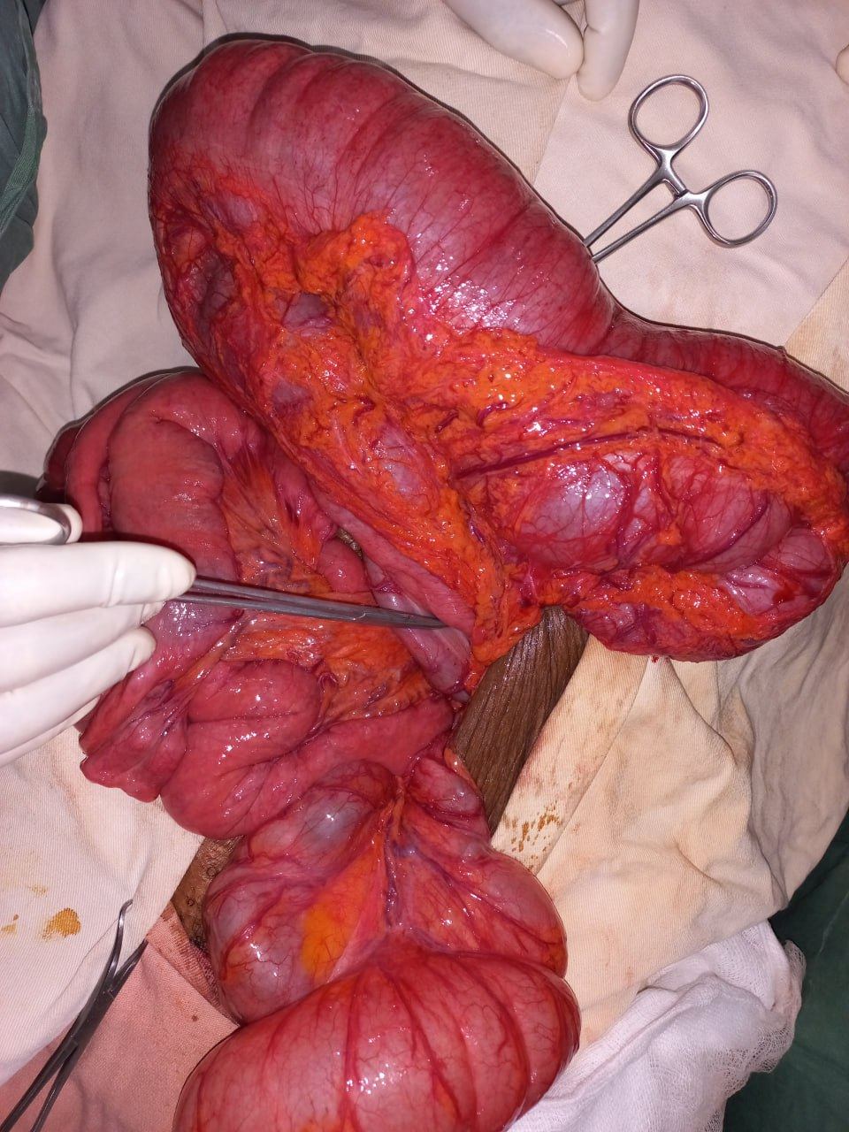

Supplemental Figure 2
